Fall 2025

Software Requirements Specification

HobbySwap - Group 1

Team members:

Aaron Ngo

Angela Marie Tagudin Chua

Jackey Zhou

Minh Thu Lu

Trung Kien Phan

PRJ566NCC

https://github.com/Zylz8/PRJ566_Group1_NCC.git

….

Executive Summary

# Background

# Description

## Company Value Add

## End-User Value Add

# Scope

## What is Included

## What is Not Included

# Justification

Table of Contents

Executive Summary 1

Background 1

Description 1

Company Value Add 1

End-User Value Add 1

Scope 1

What is Included 1

What is Not Included 1

Justification 1

Section 1 4

1.1 Document Authors 4

1.2 Document Revision History 4

1.2 Document Purpose 4

1.3 Audience 4

1.5 Group Agreement 4

Team # 1 4

Project Title 4

Project Time Frame 4

Team Members: 5

Team Leadership 5

Team Functions/Roles 5

Team Meetings 5

Team Problems 5

Teammates might have different schedules. 5

Team Commitment 5

Section 2 5

2.1 Project Proposal 5

2.1.1 Project Background 5

2.1.2 Problem Statement 7

2.1.3 Product Vision 7

2.2 Stakeholders and Users 8

2.2.1 User Personas 10

2.3 Project Scope 11

2.4 System Risks 12

2.5 Operating Environment 13

2.6 Functional Requirements 13

2.7 Nonfunctional Requirements 14

2.8 UI/UX Interface Mock-ups 15

Section 3 16

3.1 Data Flow Diagrams 16

3.2 User Stories and related Use Case Scenarios 16

3.3 Activity Diagrams 16

3.4 Business Rules 16

Section 4 – Domain Class 16

Section 5 – Database 17

Section 6 – Project Management 17

6.1 Work Breakdown Structure 17

6.2 Milestones & Acceptance Criteria 17

Section 7 – Product Backlog & Implementation Schedule 17

Section 8 – Client/Faculty Sign-off 17

References 18

Section 1

# Document Authors

Angela Chua, Minh Thu Lu, Aaron Ngo, Jackey Zhou, Trung Kien Phan

# 1.2 Document Revision History

|  |  |  |
| --- | --- | --- |
| **WEEK** | **DATE** | **Revisions** |
| 1 | Sept 18, 2025 | * Section #1 * Section #2.1 |
| 2 | Sept 24, 2025 | * Section #2.1 Revised * Section #2.2 * Section #2.3 * Section #2.4 * Section #2.5 |
| 3 | Oct 03,  2025 | * Section #2.2.1 * Section #2.6 * Section #2.7 |
| 4 | Oct 12, 2025 | * Section #2.8 |
| 5 | Nov 02, 2025 | * Section #3.0+ |
| 6 | Nov 09, 2025 | * Section #4.0 |
| 7 | Nov 16, 2025 | * Section #5.0 |
| 8 |  |  |
| 9 |  |  |
| 11 |  |  |
| 12 |  |  |
| 13 |  |  |
| 14 |  |  |

# Document Purpose

To keep track of software requirements and deliverables for HobbySwap.

# Audience

Project Team, Stakeholders, Investors, etc.

# 1.5 Group Agreement

### Team # 1

### Project Title

HobbySwap

### Project Time Frame

The semester 5 and 6 (not counting co-op)

### Team Members:

* Angela Marie Tagudin Chua
* Jackey Zhou
* Minh Thu Lu
* Trung Kien Phan
* Aaron Ngo

### Team Leadership

Aaron Ngo

### Team Functions/Roles

* Angela Marie Tagudin Chua: Frontend Developer
* Jackey Zhou: Business Analyst
* Minh Thu Lu: UI/UX Designer
* Trung Kien Phan: Backend Developer

### Team Meetings

Every Wednesday at 6pm.

### Team Problems

### Teammates might have different schedules.

### Team Commitment

The undersigned members agree to work together on the project until the end of the PRJ66 next Semester. They recognize that as a team and individually, they are equally responsible for the quality of all deliverables.

|  |  |  |
| --- | --- | --- |
| **Name** | **Date** | **Signature** |
| Angela Chua | Sept 17 2025 | Angela Chua |
| Jackey Zhou | Sept 17, 2025 | Jackey Zhou |
| Aaron Ngo | Sept 17, 2025 | Aaron Ngo |
| Minh Thu Lu | Sept 18,2025 | MTL |
| Phan Trung Kien | Sep 18, 2025 | Kevin |

Section 2

# 2.1 Project Proposal

## 2.1.1 Project Background

With the surge in popularity of collectibles like Pokémon cards and blind boxes (Smiski, Labubu, Sonny Angel), it’s surprising that there isn’t a mainstream platform dedicated to facilitating trades. Collectible trading is fragmented across unsafe platforms (Facebook, eBay, conventions). There is a need for a dedicated, trusted, and user-friendly system to facilitate trades. HobbySwap builds on the insights gained from the PokeSwap prototype, HobbySwap now offers a wider range of collectible categories.

**Current Competitors:**

**Facebook Marketplace:**

Facebook Marketplace provides free local listings that allow the users to buy and sell items within their community *(Facebook, n.d.).* The features of Facebook Marketplace include local search filters, category browsing, built-in messaging through Facebook Messenger, ratings and reviews, and integration with user profiles for transparency. Despite these advantages, Facebook is not optimized for dedicated item-to-item swaps. Most trades are cash-based, and exchanges require informal arrangements between the users, which often leads to miscommunication or disputes. There is no trusted service, shipping protection, or structured system to verify the authenticity of collectibles, leaving collectors at risk of scams or counterfeit items. The completed trades are difficult to track, making it difficult for users to build a reliable reputation within the Marketplace.

**eBay:**  
eBay is one of the largest global e-commerce platforms and a dominant marketplace for collectibles, including trading cards, figurines, and other hobby items *(eBay, n.d.).* Its features include auction-style and fixed-price listings, buyer and seller ratings, global reach, secure payment integration with PayPal, and purchase protection programs that cover certain disputes. eBay's search filters, categories, and item tracking tools make it easy for collectors to find rare or high-value items. However, eBay is heavily cash-based, and while it does do buying and selling, it does not provide a structured item-for-item trading option. Sellers also face high commission fees (generally 10-15%), which can discourage smaller trades of exchanges of low-value collectibles. Also, shipping costs and delays can make casual trading less likeable. While there is buyer protection, disputes are often time-consuming.

**StockX:**

StockX is a trusted online marketplace primarily used for buying and selling sneakers, streetwear, trading cards, electronics and more. *(StockX, n.d.)* One of its advantages is that all products go through StockX’s authentication process, acting as a middleman to verify items before they reach the buyer. StockX uses a bid/ask system where sellers list their asking price, and buyers place bids. This system does not provide a way of offering other collectibles to complete a transaction. Another limitation is the lack of an integrated chat or messaging system, which means users have no way of directly negotiating.

**Conventions:**

Collector conventions (Toronto Card Show, Anime North, or Comic-Con events) provide an in-person environment where buyers, sellers, and traders can meet face-to-face. Their features include direct item inspection, live auctions, vendor booths, and the ability to trade or negotiate in real time. Collectors can verify authenticity and quality of the items before committing to a deal. Conventions also build community by creating an interactive experience where collectors can network with like-minded hobbyists. The downsides are conventions are limited to specific dates and locations, often requiring admission fees and travel costs. Many vendors undervalue items, offering only 70-80% of the market value when buying from collectors.

|  |  |  |  |
| --- | --- | --- | --- |
| **Application** | **Key Features** | **Lack of Features** | **Cons** |
| Ebay | - Global reach  - Auction + fixed pricing  - Buyer protection  - Seller/buyer ratings | - No item-for-item trading  - No direct chat  - High fees | * 10–15% seller fees * No trade options * Time-consuming dispute resolution |
| StockX | - Authentication service  - Bid/Ask pricing system  - Secure transactions | - No chat or negotiation - No item-for-item trading - Only certain categories supported (Mostly clothes, not toy collections) | * No trading, only buying/selling * Not community-focused * Limited product range |
| Facebook Marketplace | - Local listings - Facebook Messenger integration - Free to use | - No item verification - No structured trade system - No transaction protection | * High scams risk * No reputation system * Trades are informal & risky |
| Conventions | - In-person trading  - Live auctions  - Community networking | - Not available year-round  - No digital infrastructure | * Requires travel & fees * Can’t scale beyond events * No trade tracking system |

## 2.1.2 Problem Statement

Collectors today face major challenges when trying to complete or manage their collections. Platforms like Facebook Marketplace, eBay, or conventions are currently the most common methods used for trading and selling collectibles. However, these platforms are not designed for direct item-for-item exchanges and often leave collectors exposed to scams, inflated prices, and unreliable trade partners. For parents and younger collectors, these risks are even more serious as they lack a safe environment to swap or purchase items. Conventions, while they are a safer option, are limited to specific dates, require entry fees, and only provide temporary opportunities to trade. As a result, for the average collector they will either pay high reseller markups or take risks in unregulated online communities.

The lack of a mainstream, trustworthy, and efficient trade system creates inefficiencies that harm both casual and serious collectors. Blind box collectibles such as Labubu and Smiski are intentionally designed against you randomly opening the item you want. Without a safe trade system, those items often go to waste or flood unregulated marketplaces. Similarly, the resurgence of Pokémon cards, some selling for thousands of dollars or even millions, highlights the scale of value being exchanged in unsafe environments. Collectors now need a secure, transparent, trustworthy, and easy-to-use platform that not only connects them to others but also ensure fair trades, prevents scams, and promotes a healthier collector community.

## 2.1.3 Product Vision

To close the gap between serious collectors, sellers, and causal hobbyist, we aim to establish a reliable online marketplace and community platform where collectors can trade collectibles in a fair and secure manner.

HobbySwap introduces key features designed to address the shortcomings of existing solutions:

* Free Listing and Browsing – Users can explore available items at no cost, with filtering and sorting by category
* Flexible Swap Requests – Collectors can post listings requesting specific collectibles, cash, or a combination of both
* Integrated Chat – On-platform messaging allows users to connect, negotiate and confirm trade details
* Affordable & Fair – Users get more value for their items compared to selling to vendors or local stores. Fees only apply for remote trades where shipping protection is required, while local trades remain free.
* Trust and Safety - Securing partnerships with other reputable platforms such as Collectr and TCGPlayer would establish credibility and foster trust in our platform. Users will ship their items to HobbySwap for authentication. Once verified, the platform completes the swap by sending the items to their new owners. Upon completing trades, users will have a chance to rate their trade partner, allowing them to gain reputation over time.

# 2.2 Stakeholders and Users

**Internal:**

|  |  |  |
| --- | --- | --- |
| **Role** | **Name** | **Description** |
| Product Owner | Aaron Ngo | Oversees the overall product vision and ensures alignment with user needs and business goal |
| Frontend Developer | Angela Chua | Responsible for implementing user interface components and ensuring accessibility and responsiveness |
| UI/UX Design | Minh Thu Lu | Design user flows and interfaces to ensure a smooth and intuitive user experience |
| Backend Developer | Trung Kien Phan | Develops APIs, handles data process, user authentication, and implements trade logic |
| Business Analyst | Jackey Zhou | Conducts market research, competitor analysis, and aligns features with user needs |

**External:**

* **Partners**

***Trading cards, toys, blind boxes store***

* They are local hobby shops, anime stores, card retailers, and related businesses that we collaborate with to grow the HobbySwap platform from the ground up. These partnerships can begin with simple, low-barrier collaborations such as putting up posters, distributing flyers, or featuring HobbySwap in-store (e.g., via a QR code, window sticker, or shelf signage).
* In return, we will promote them on HobbySwap's website/app/social media as official trade-friendly locations, driving visibility among local collectors. Stores can advertise their inventory or special promotions directly on the HobbySwap platform, reaching a highly targeted audience of collectors. When having enough amounts of users, they will co-host exclusive in-store or pop-up trade nights with HobbySwap (e.g., Pokémon swap meet, blind box trading party), driving event-specific sales.
* Some research on few stores we will contact: Wheels &Wings Hobbies (located at The Danforth), VTR Gaming (located Mississauga Valley), Emmett’s ToyStop (located Etobicoke), L&M Trading (located downtown Toronto), GameSwap (located Scarborough), etc.

***Content Creators on Social Media***

* Influencers, YouTubers, TikTokers, and Instagram creators who specialize in collectibles, such as Pokémon cards, anime merchandise, blind boxes, or toy unboxings, are key promotional partners for HobbySwap. These individuals have direct influence over niche audiences who already trust their opinions and follow their collecting habits.
* We aim to collaborate with content creators by offering them early access to the platform, exclusive trading features, or opportunities to host giveaways, unboxings, or trade challenges sponsored by HobbySwap. In exchange, they’ll help us build hype, educate their followers about how to use the app, and generate trust and interest through authentic content.
* This collaboration can start simply through a sponsored post, but can grow into long-term ambassador roles, where creators host virtual or in-person swap events, or become featured collectors on the platform.
* Some popular accounts: [PokeRev](https://www.youtube.com/@PokeRev) (3.13M subscribers), [WolfeyVGC](https://www.youtube.com/channel/UC9OZkS1Mhl5UvKSiPrYqsxg/videos) (1.9M subscribers), [DeepPocketMonster](https://www.youtube.com/@deeppocketmonster) (1.8M subscribers), [shofu](https://www.youtube.com/channel/UCbr6TI0Mujw2iFAQE4R8yrQ/) (167k subscribers)
* **Investors**
  + Investors are individuals or firms who provide the funding needed to support the development and growth of the HobbySwap platform. This early financial support helps us build new features, expand our marketing reach, and scale our user base. While their input may help shape certain business strategies, investors are not intended to be the driving voice behind the platform’s vision or community direction.
  + In return, investors benefit from holding equity in HobbySwap, meaning they share in the company’s success as it grows in popularity and value. As the platform scales, investors may see returns through profit shares, future acquisition opportunities, or the increased value of their ownership stake.
  + We plan to connect with investors through startup events, pitch competitions, angel networks, and crowdfunding platform.
* **Users:**

***Collectors:***

* Users, primarily collectors of trading cards, toys, blind boxes, and other hobby items, are the heart of the HobbySwap platform. They use the service to discover, trade, and connect with other enthusiasts in a safe and trusted environment. Their active participation drives the community and keeps the marketplace vibrant.
* Users benefit from an easy-to-use platform designed specifically for item-for-item trades, secure messaging, trade tracking, and reputation building. Their feedback and trading habits are crucial for improving HobbySwap and expanding its features.
* We will engage users through targeted marketing, partnerships with stores and influencers, and by fostering an active community where collectors feel valued and supported.

***Business:***

* Business accounts represent local hobby shops, resellers, and traders who use HobbySwap to showcase their inventory, reach a broader audience, and facilitate trades or sales with collectors and other businesses. They gain access to promotional opportunities, inventory advertising, and tools to manage trades efficiently. By joining the platform, businesses can expand beyond physical locations, participate in community events, and build a loyal customer base within the collector ecosystem.

## 2.2.1 User Personas

**Name: Matthew Matthews**

**Age: 45**

**Occupation: Accountant**

Matthew finds working a 9-5 tiresome, and managing his kid’s hobbies takes even more out of him. His only daughter loves collecting Labubu, however he struggles with knowing where to look. He feels that places that sell Labubu blind boxes in-person are rare. He also doesn’t completely trust sites like Facebook Marketplace, as other sellers may sell counterfeit figures. He wants a website that he can not only trust is reliable but can also be quick and provide a wide selection of Labubu.

Question 1: **When buying Labubu blind boxes online, what sites do you check first and why?**  
Answer: "I usually check **Facebook Marketplace** and **eBay** because that's what my co-workers recommended, but honestly I **don't trust either of them**. I have seen way **too many counterfeits** on both Facebook Marketplace and eBay. I would prefer a website where **every user is verified** and has **system to check if they are trustworthy**"

Question 2: **When ordering Labubu blind boxes online are there any features that would matter to you?**  
Answer: "I would say tracking and insurance would be the most important to me. I **wouldn't mind paying a bit extra** to **ensure they arrive safe,** and I can **see where it is**. I also like the idea of being able to **confirm or cancel a trade**."

**Name: Jacob Pilzner**

**Age: 27**

**Occupation: Store Manager**

Jacob owns a local card shop in the small city of Goose Bay, Ontario. His business is doing decent in-person, but he’s also interested in expanding his reach. While websites like Cardtrader and TCGPlayer exist as online marketplaces for his businesses, as his store sometimes sell other products like figurines, he’s also interested in hosting his business on a website that can cover a variety of collectables.

Question 1: **Since your local card store sells a variety of items, what features would you like to see in our platform to help customers find your listings easier?**

Answer: “I think my customers would appreciate a platform where they can **filter through different categories** of products **by type**, for example cards, figures, plushies, and more. Additionally, we could allow them to narrow the search even more by allowing them to **sort by brand**.”

Question 2: **What type of security features would you use to ensure that your business would not get scammed, have fraudulent buyers, or chargebacks?**  
Answer: "I'd ensure that we use a **third-party payment system**, something like **PayPal** or **Stripe**. A **rating system** would help as well or **verification** to know who I'm selling or trading to. That way, I can ensure I’m trading with **reliable accounts**”

Question 3: **What feature do you think is most important in a platform where users trade collectibles with each other?**

Answer: “As a collector myself, it’s rare for me to ever simply accept a trade at its listed price. It’s **in our nature** **to** **haggle**, so I believe **integrated messaging** is essential for a platform like this. Users will appreciate an **easy way to communicate** and **hash things** **out** with each other.”

# 2.3 Project Scope

**What are included:**

* Creating a suitable back-end to store user and product data, and a suitable front-end to show this data.
* Choosing what libraries to use (React-based, Express-based, etc.), in addition to choosing on how to style the front-end (custom CSS, or a pre-set library like Bootstrap or Tailwind)
* As it involves storing user data, a back-end module that encrypts sensitive data must be included (i.e. bcrypt if based on Node).
* Must exchange of goods between users. Users need to communicate with other when exchanging, so a chat system must also be made. This chat system should also monitor messages for unauthorized activity (i.e. scams, illegal activities, etc.).
* A moderation system should be included in the site to protect against bad-faith actors, for instance, reporting a user if they are showing obscene content, or if they are promoting un-authorized services outside of the site.
* This project primarily involves trading collectables like trading cards, blind boxes, etc. A guideline that focuses on what should be hosted on the site should therefore be included.

**Out of Scope:**

* Forums: while collecting can be community based, our website is specifically focused on the trading experience itself.
* Native Mobile App (iOs/Android): We will focus on responsive web platform first to reduce complexity
* Auctions/ bidding system: focus on item-for-item trade focus, this will be future development.
* Cross-platform Integration: focus on within the application for now, will not sync with Ebay, Amazon, or other marketplaces. What risk from previous features?
* Cloud-based website

# 2.4 System Risks

|  |  |  |  |  |  |
| --- | --- | --- | --- | --- | --- |
| **Risk** | **Project Relevance** | **Likelihood** | **Impact** | **Risk Level** | **Mitigation Strategy** |
| Users Scams/ Fake Profile | Trust is essential to building a strong user base. Without an effective verification system, or close monitoring, users are unlikely to feel safe on the platform, hindering engagement. | High | High | Critical | Add identity verification, limit unverified user actions, build reputation system |
| Low adoption/Engagement | HobbySwap’s success depends on cultivating a large, active community. Since the platform acts as an intermediary, user activity directly determines its usefulness. | Medium | High | High | Market to niche communities (ex. Facebook group, and influencer promote on social media)  Run early beta testing |
| Data Loss | The platform stores important information such as user accounts, listings, trade history, and messages. Losing data would damage user trust, disrupt operations, and make it difficult for collectors to rely on our platform | Low | High | Critical | Use the 3, 2, 1 method when storing data (3 places data is stored, 2 in different devices, 1 off-site), always make back-ups |
| Fraud/Counterfeit Items | Fraud incidents could significantly damage user trust. Even if HobbySwap is not directly liable, collectors may hold us responsible, discouraging others from using it. | Medium | High | High | Have users send collectibles to HobbySwap for verification before they’re shipped to their new owners. If items are mismatched with trade details, they will be sent back. |
| Users Canceling Trades After Agreement | Two users may agree to a trade, but one cancels before the exchange happens. This scenario is demoralizing to the other user, wastes their time, and reduces trust in the platform if it often occurs. | Medium | Medium | Medium | Allow users a 2-hour window to cancel after confirming a trade. Enforce a strict policy on frequent cancellations by limiting the number allowed per month. Frequent cancellations directly affect reputation system. |
| Product is missing in the DB | Incomplete product data hurts usability and could affect adoption if users can’t find what they’re looking for. | Medium | Low | Low | Periodically update the database with new products |
| Shipping Delays/Cancellations | Our users might want to remotely trade with each other, however unexpected shipping delays and cancellations might occur during the process. | Medium | High | Medium | Notify the users of possible shipping disruptions in advance. Provide alternatives if their shipping method of choice isn’t available. |

# 2.5 Operating Environment

The HobbySwap application functions as a Progressive Web App and as a standalone mobile app for Chrome, Safari, Firefox, and Edge on Mac, Windows, and Android devices. Frontend development is done through React, Next.js, and TypeScript, while packaging is done using Node.js 20+ and is streamed over HTTPS. The app track inventory and track slow-moving stock on consignment and allocate swap stock for in-store swap events. Event trade nights and track participants with swap volumes. The app integrates swap workflows, manage catalogs, and distribute leads to stores.

* Hardware Environment:

- Scalable Services: Ensuring servers can handle peak loads

- Reliable Hardware: Using high-performance, dependable hardware

- Network Redundancy: Implementing stable, uninterrupted network connections

* Software Environment:

- Stable OS: Using reliable operating systems for all devices

- Database Integration: Seamlessly integrating with leading database systems

- API Integration: Maintaining APIs for software integration

- Continuous Deployment: Rapidly deploying new features

* Security Environment:

-Advanced Security Protocols: Implementing end to end encryption

- Threat Monitoring: Utilizing real-time threat detection

- Security Audits: Conducting regular vulnerability assessments.

- Data Encryption: Protecting data in transit and at rest

# 2.6 Functional Requirements

**General Requirements:**

* **Profile management**
  + Users can create accounts, log in, manage their profiles
* **Item Listings**
  + Users can create, edit, and delete listings for collectibles they want to trade
* **Offers and Offer Management**
  + Users can send, accept, or decline offers for their listed collectibles

**Interview Suggested Requirements****:**

* **Searching and Browing**
  + Users can **search, filter by category**, and browse listings
  + *(Jacob requested categories such as “cards, figures, plushies” with brand filters so his customers can find his diverse product range more easily)*
* **Messaging/Communication**
  + Users can **message each other** to **negotiate trades** or connect with other collectors
  + *(Jacob noted that haggling is part of collector culture, making integrated messaging essential)*
* **Reputation System**
  + User accounts will have a **reputation score** tied to it
  + Users can rate each other upon completing a trade
  + Frequent cancellations will impact reputation
  + Accounts with poor reputation will receive reduced visibility on the platform
  + *(Jacob suggested that a rating/verification system is critical to help sellers avoid scams and identify trustworthy buyers/sellers)*

# 2.7 Nonfunctional Requirements

**General Requirements:**

* **Accessibility & Usability**
  + UI will be simple with consistent navigation and accessibility
  + Users should be able to browse listings and complete a trade process with minimal steps

**Interview Suggested Requirements****:**

* **Trustworthy**
  + The web app must be safe for users to let go of potentially expensive collectibles
  + There should be a system in place to **deal with counterfeits/scams** to encourage users to use the platform
  + *(Addresses Matthew’s frustration with counterfeit Labubu on eBay and Facebook Marketplace)*
* **Payment Integration**
  + A **secure, third-party payment system** (**PayPal, Stripe)** must handle financial transactions for shipping costs and optional item purchases
  + Payment transactions should be confirmed within 5-7 seconds to avoid user frustration
  + *(This aligns with Jacob’s security preference for trusted providers to avoid fraudulent transactions)*
* **Shipping**
  + Users must be provided with multiple shipping options depending on location, item type, and **cost preference**
  + The system must display **estimated delivery times** and **shipping costs** at the point of trade confirmation
  + Users should be **able to track shipments** through integrated carrier tracking APIs
  + *(Matthew emphasized tracking and insurance as the most important feature for peace of mind when ordering Labubu)*

# 2.8 UI/UX Interface Mock-ups

## 2.8.1 Sign-up and Login

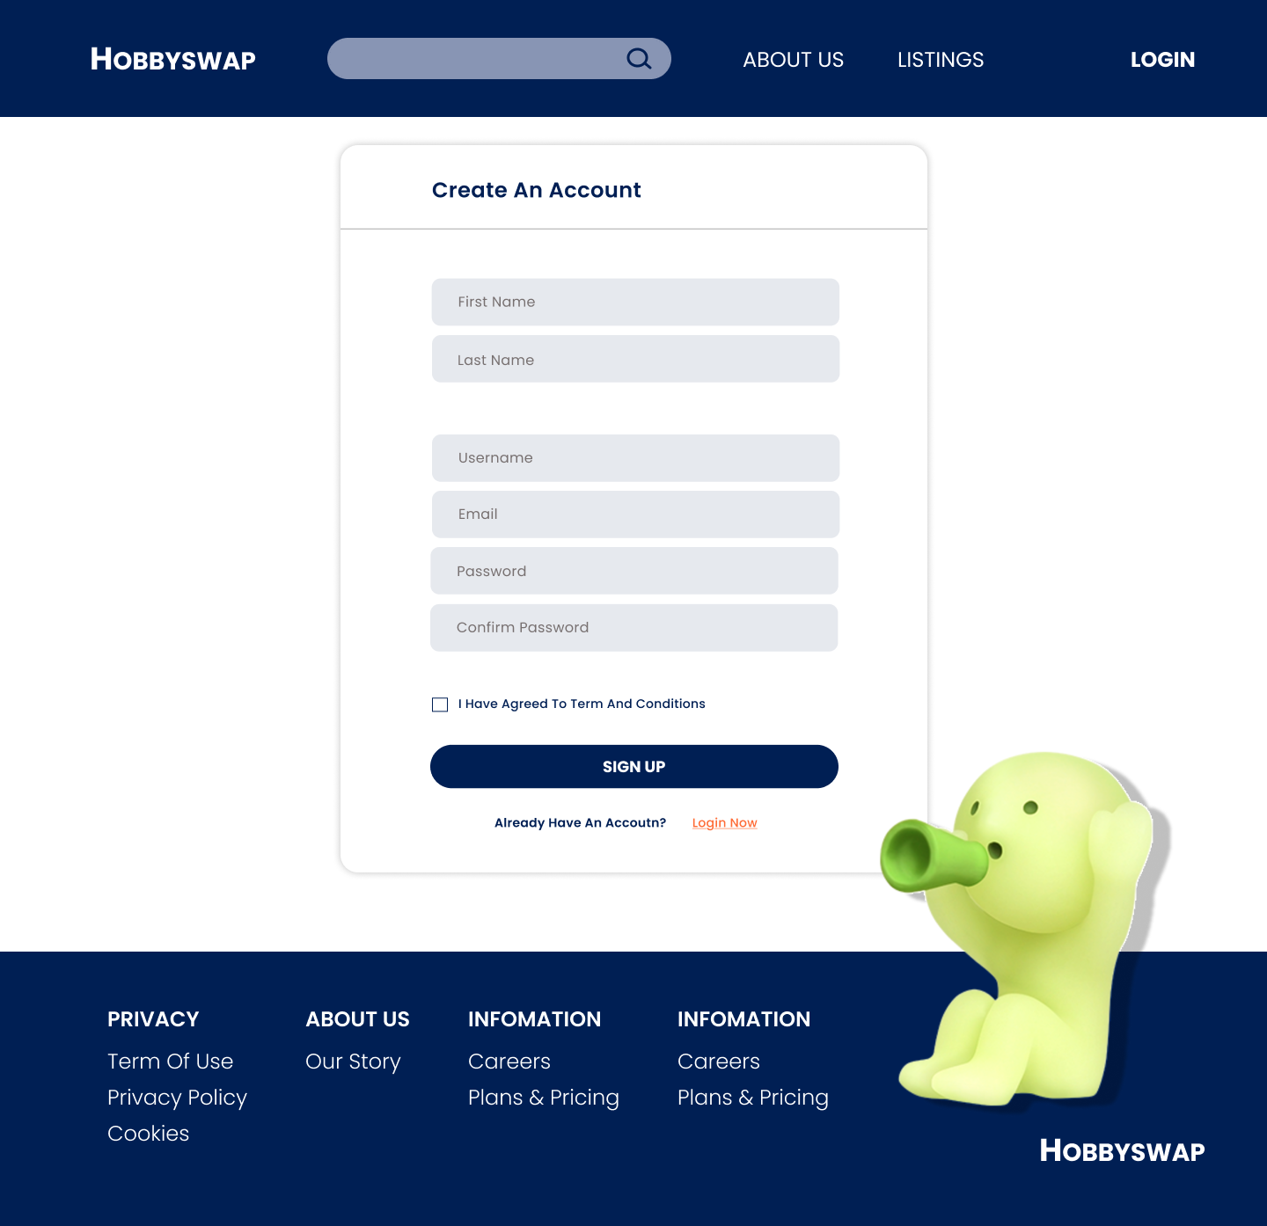 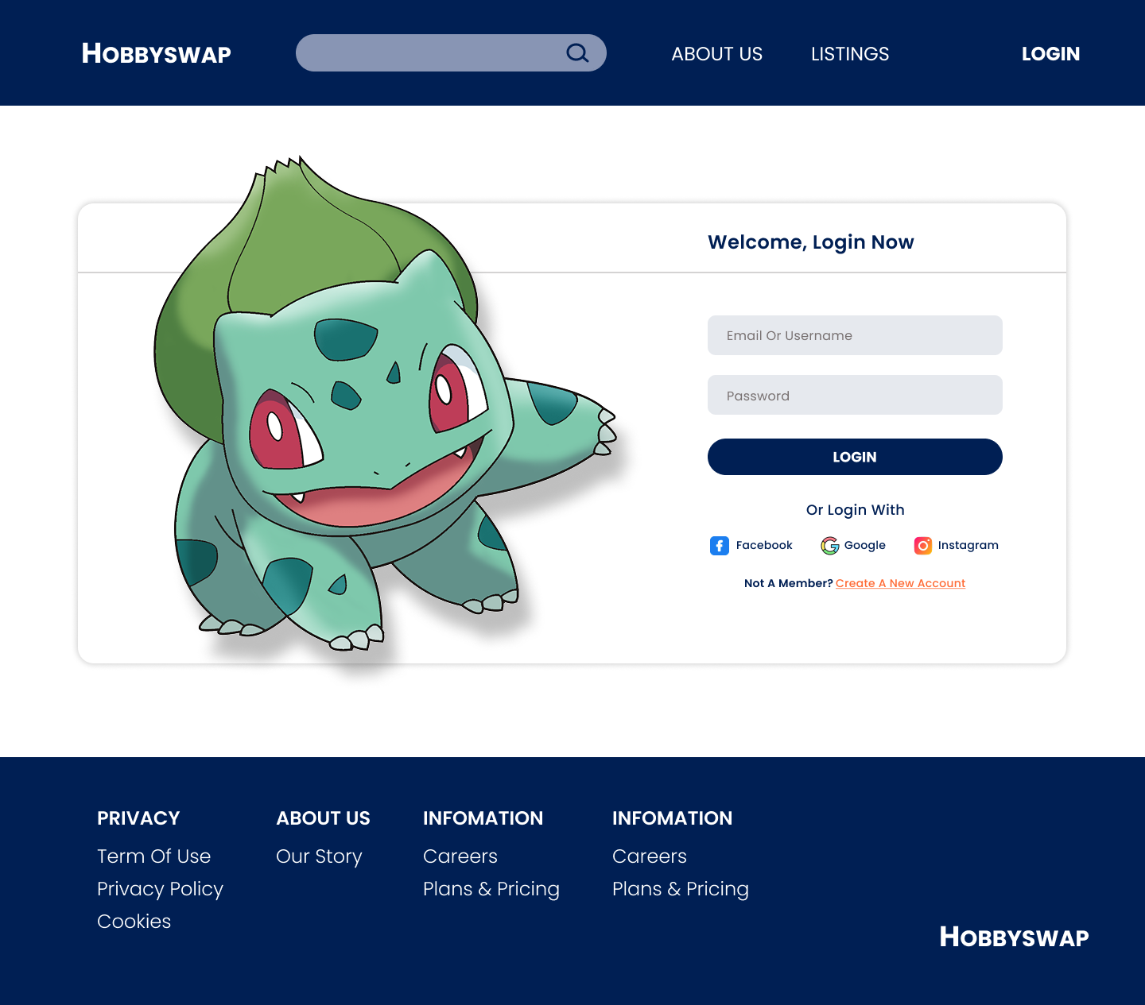

## 2.8.2 Create and Updating Listing

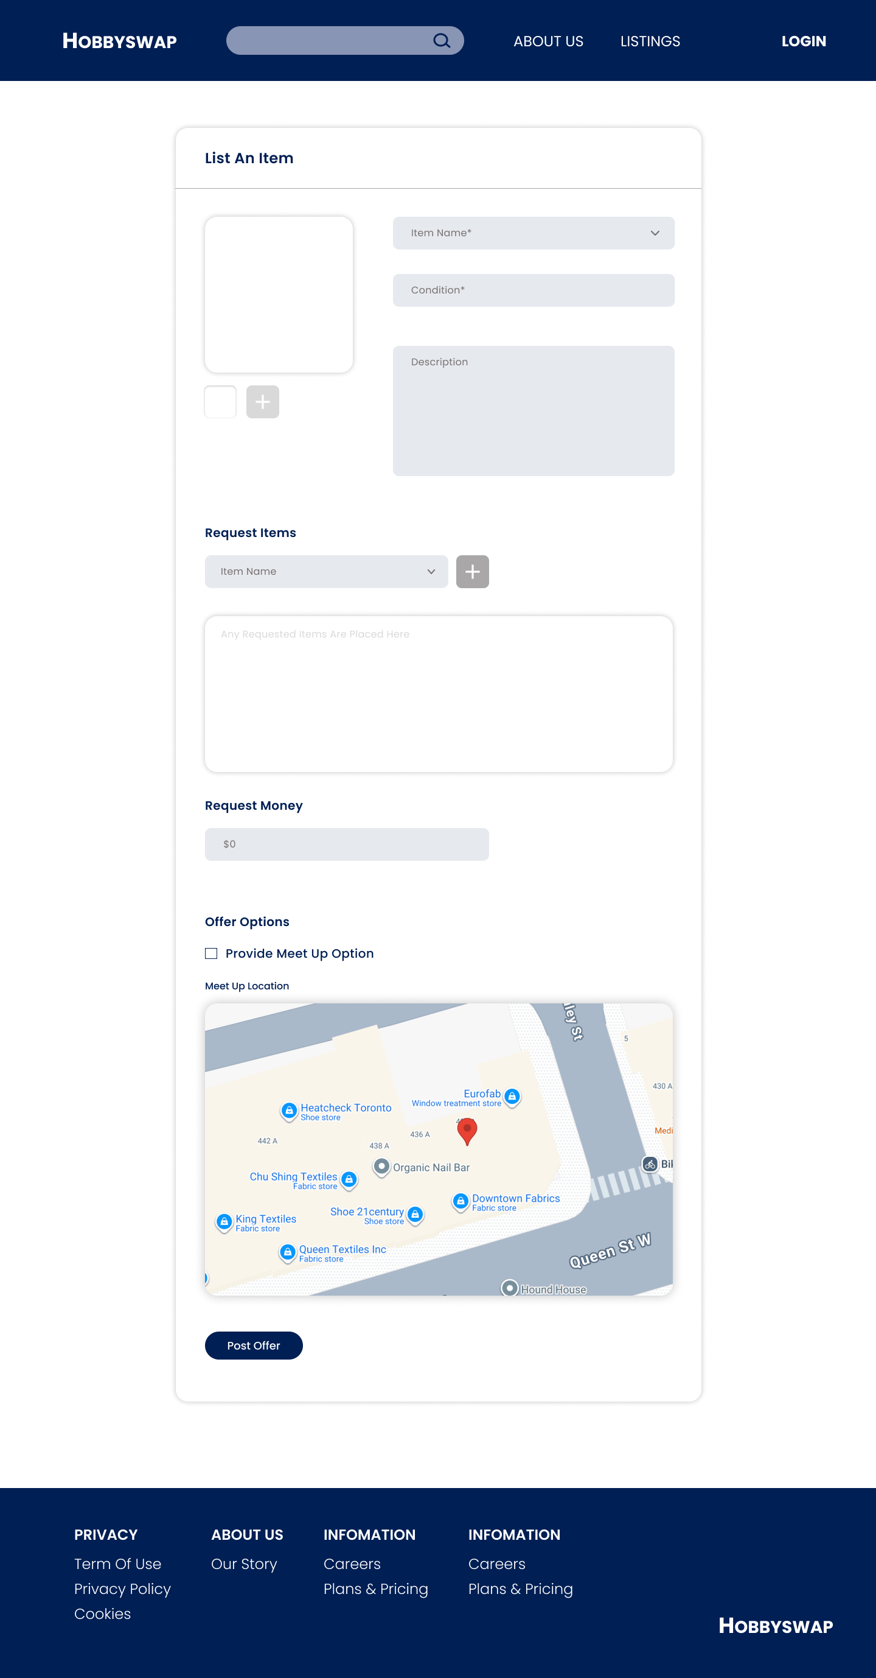 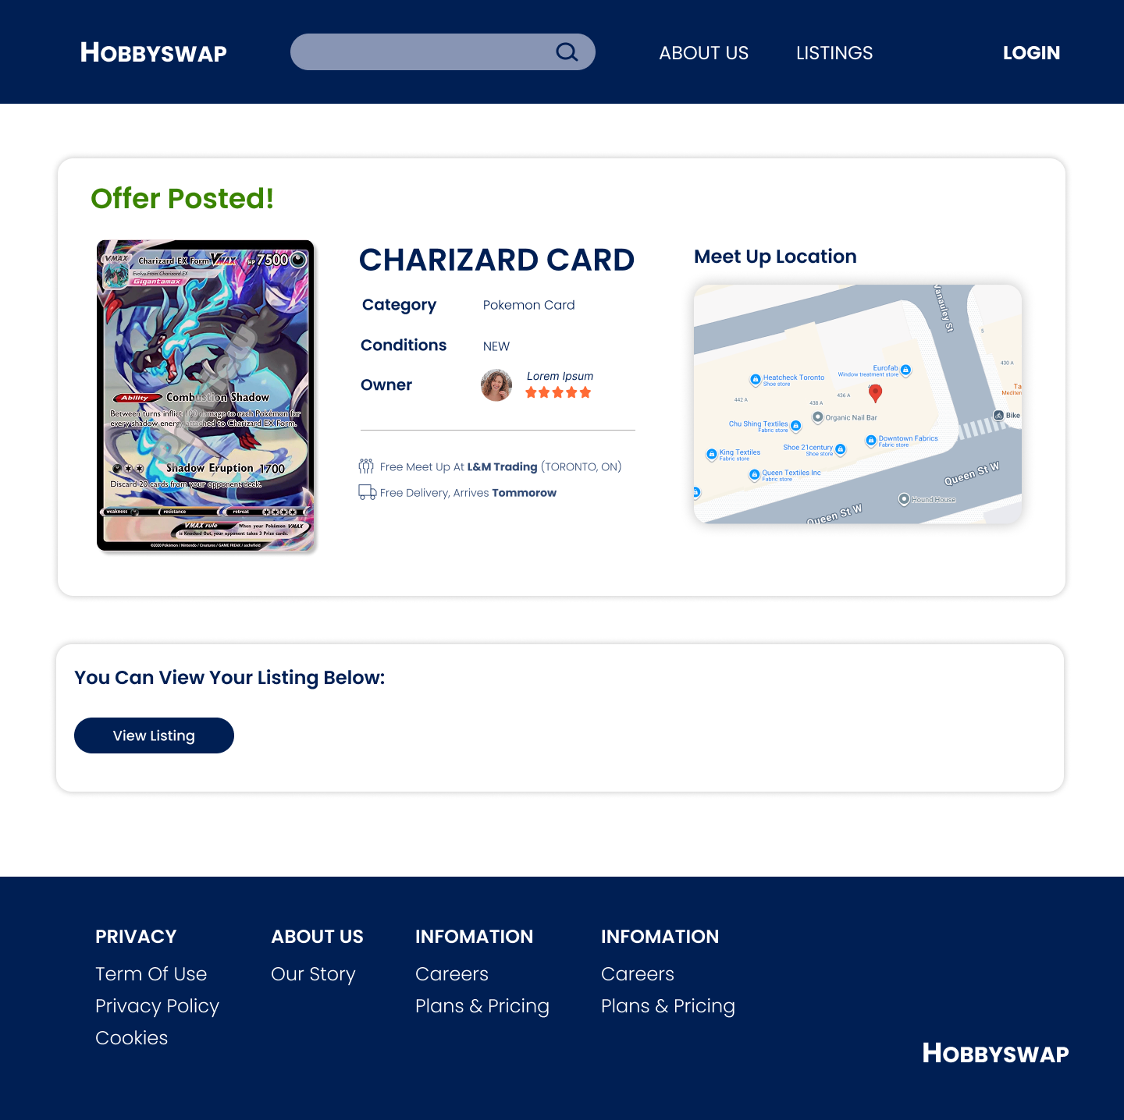

## 2.8.3 Listing Page and Product Details

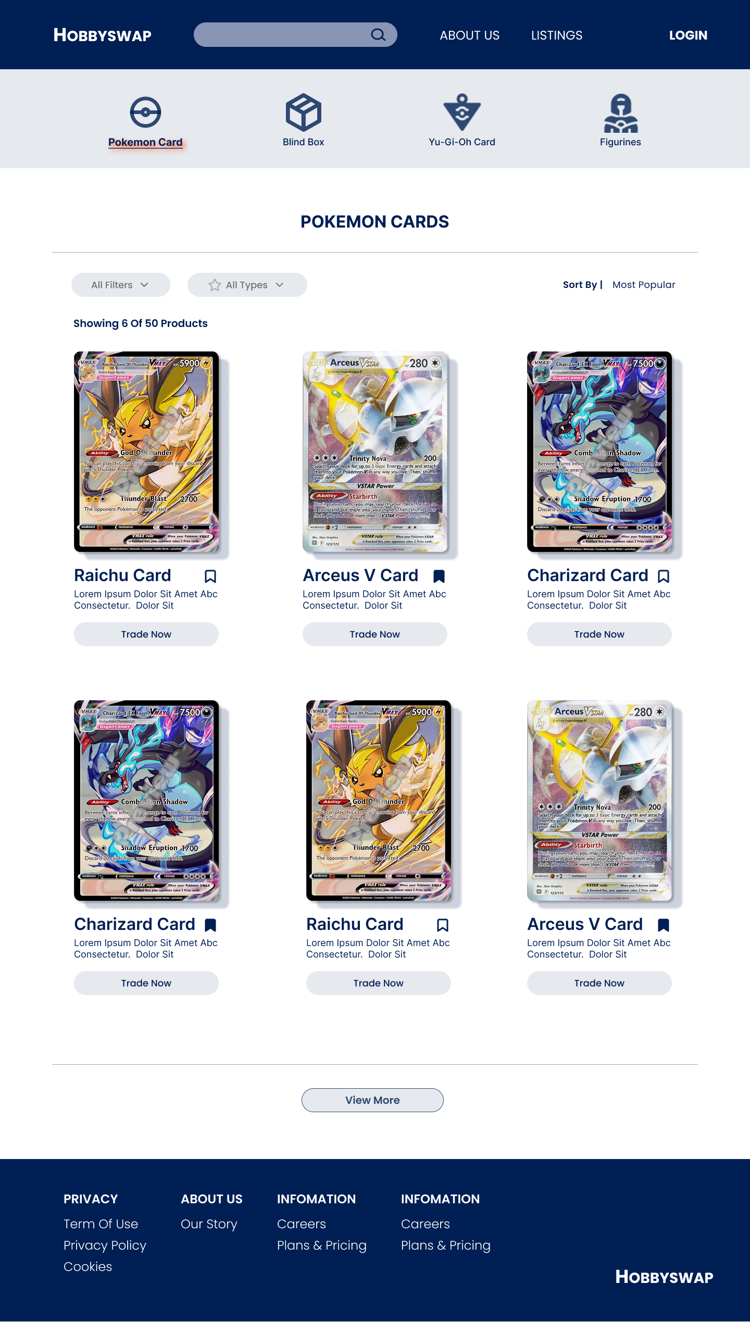 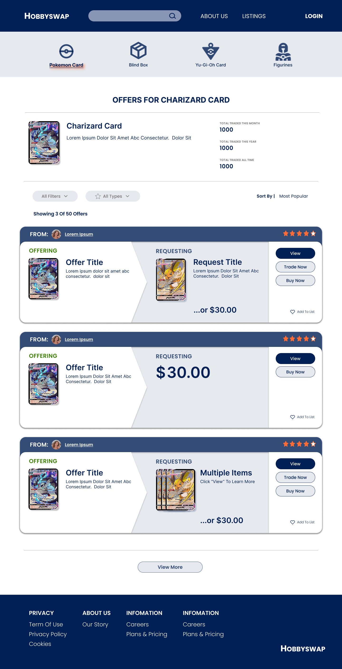 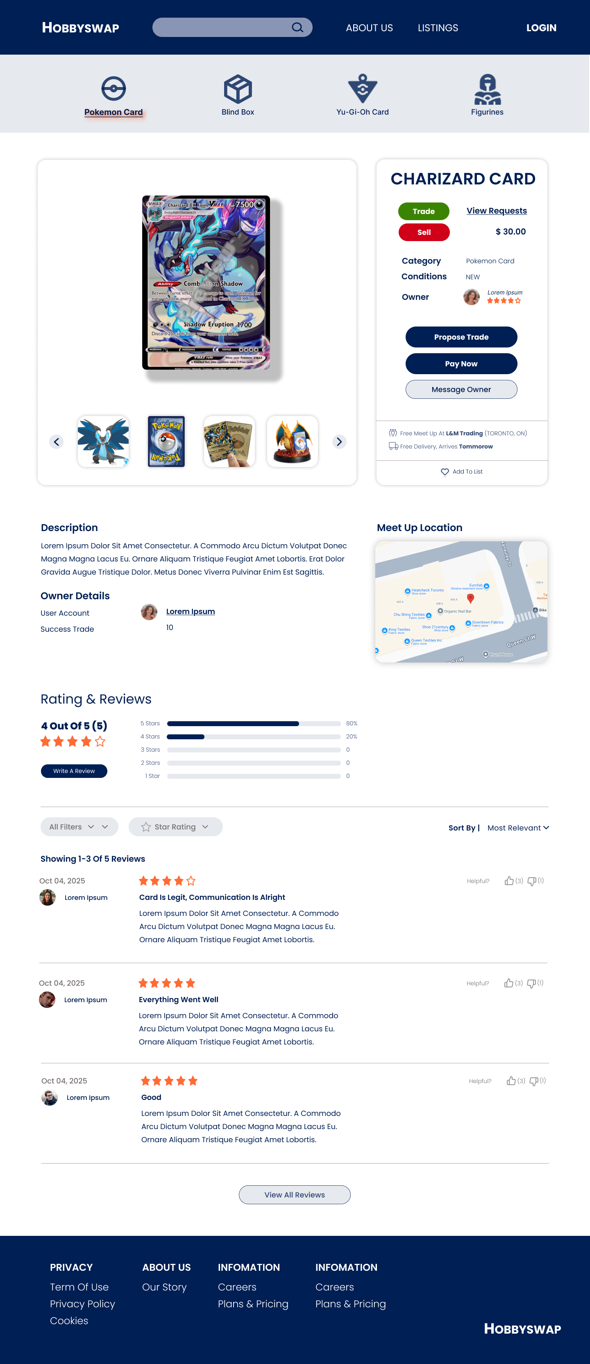

## 2.8.4 Trade Related Page

**1. Messaging Owner**

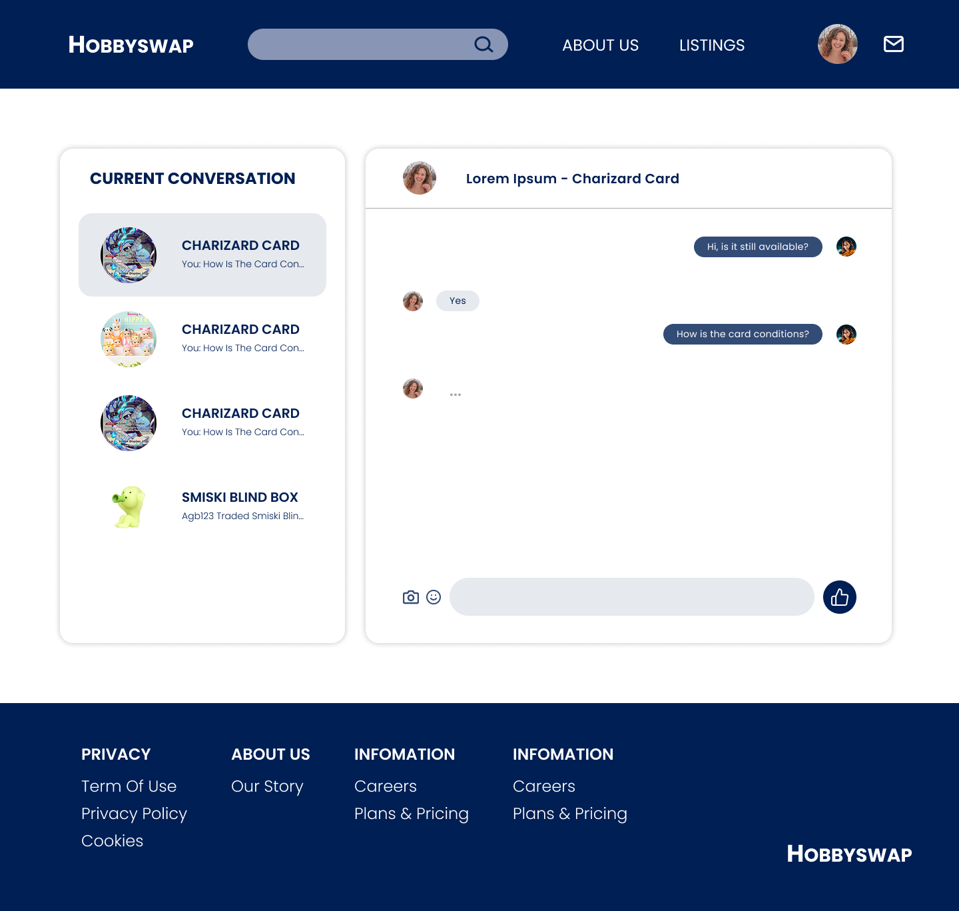

**2. User Listing & Accept/Decline Trade**

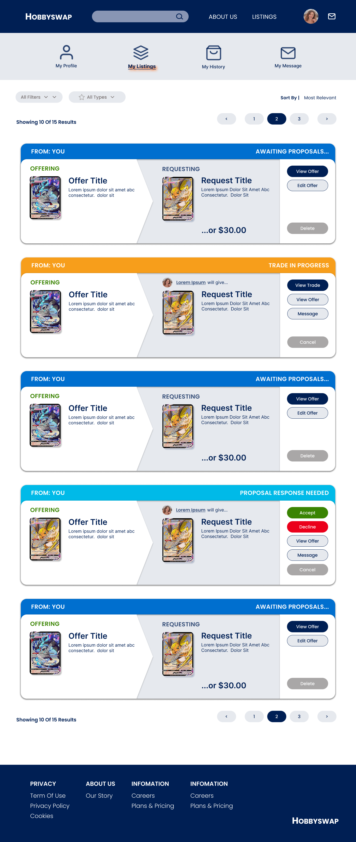

**3. Trade confirmation**

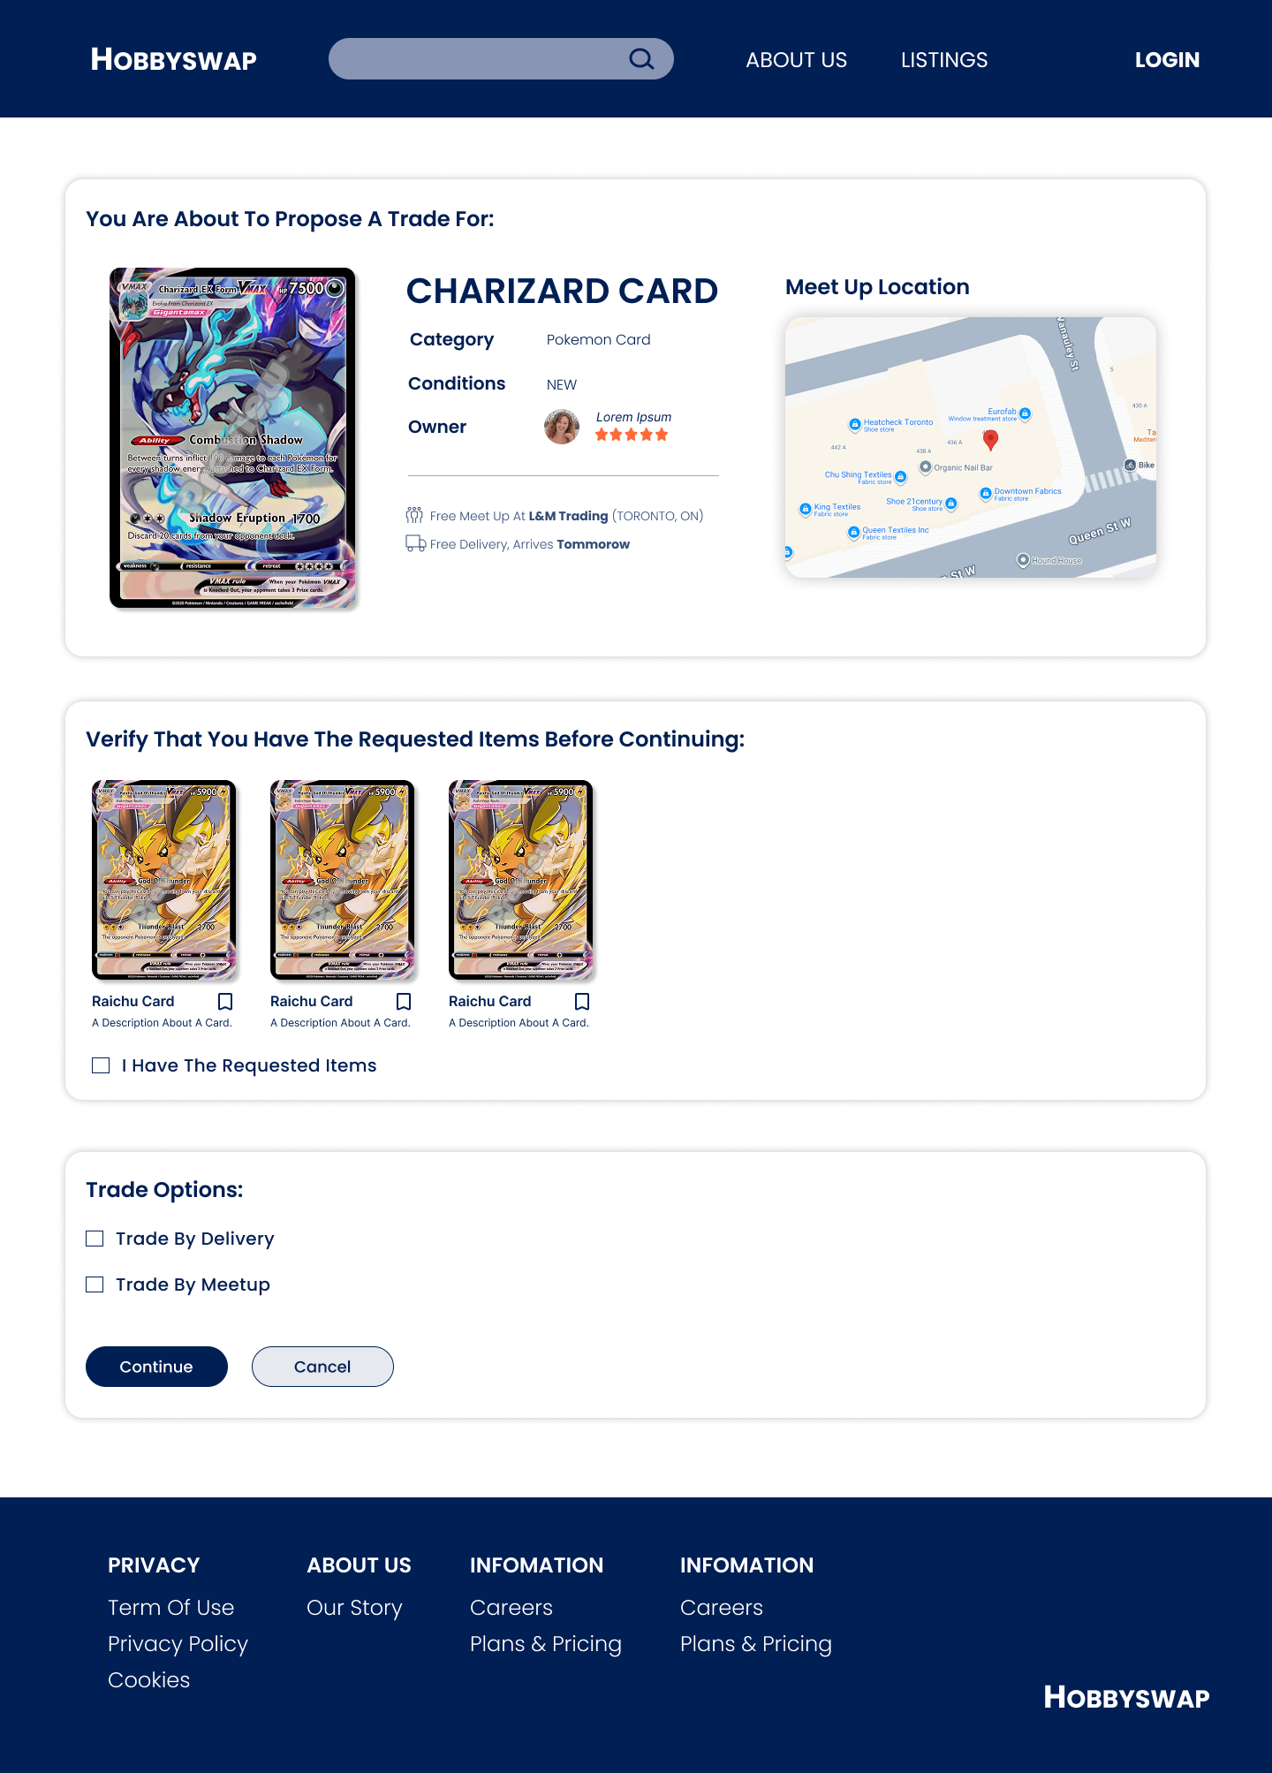 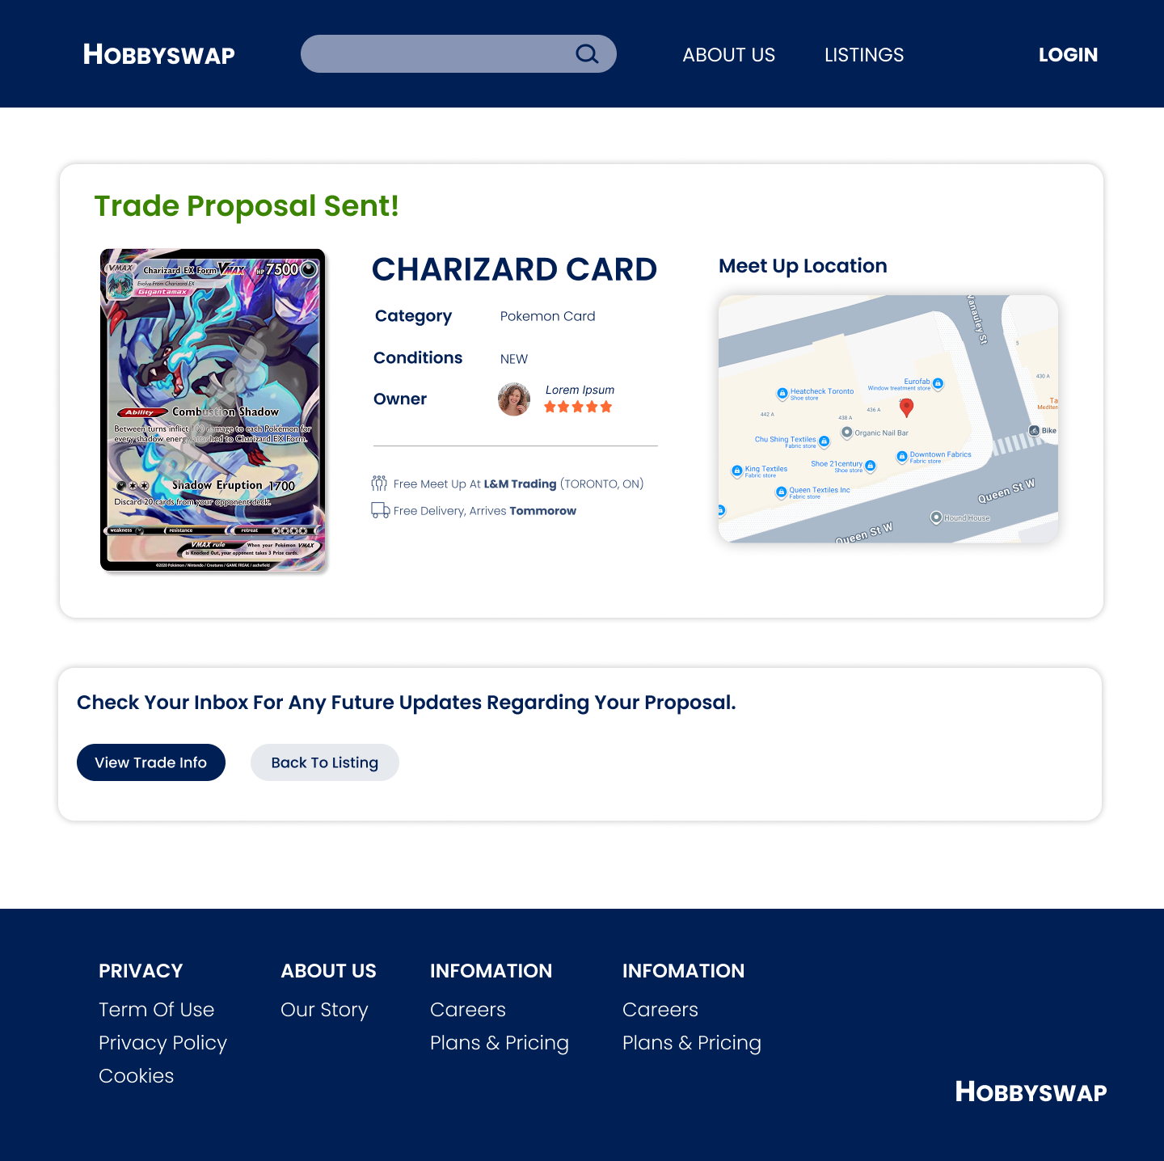

**4. Trade tracking**

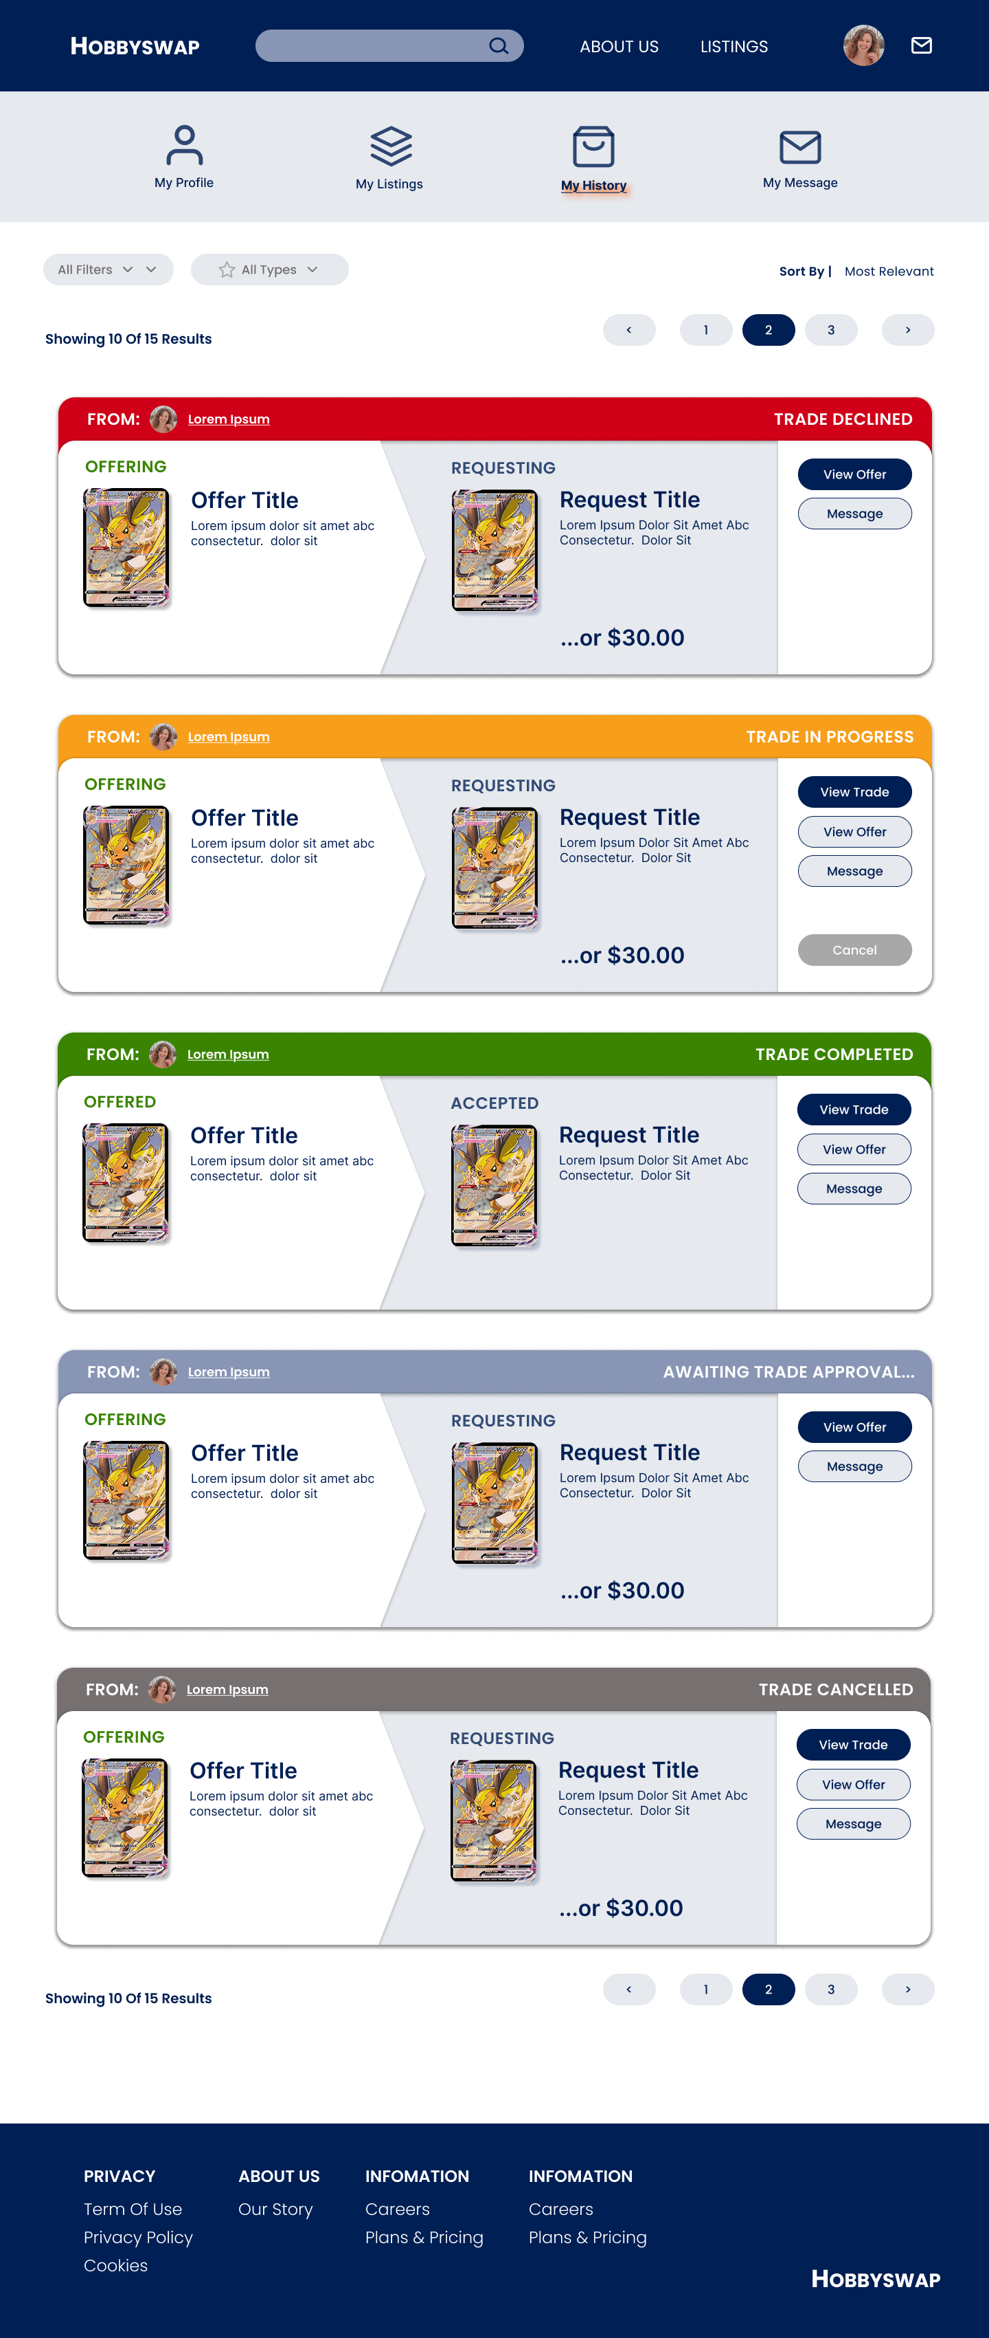

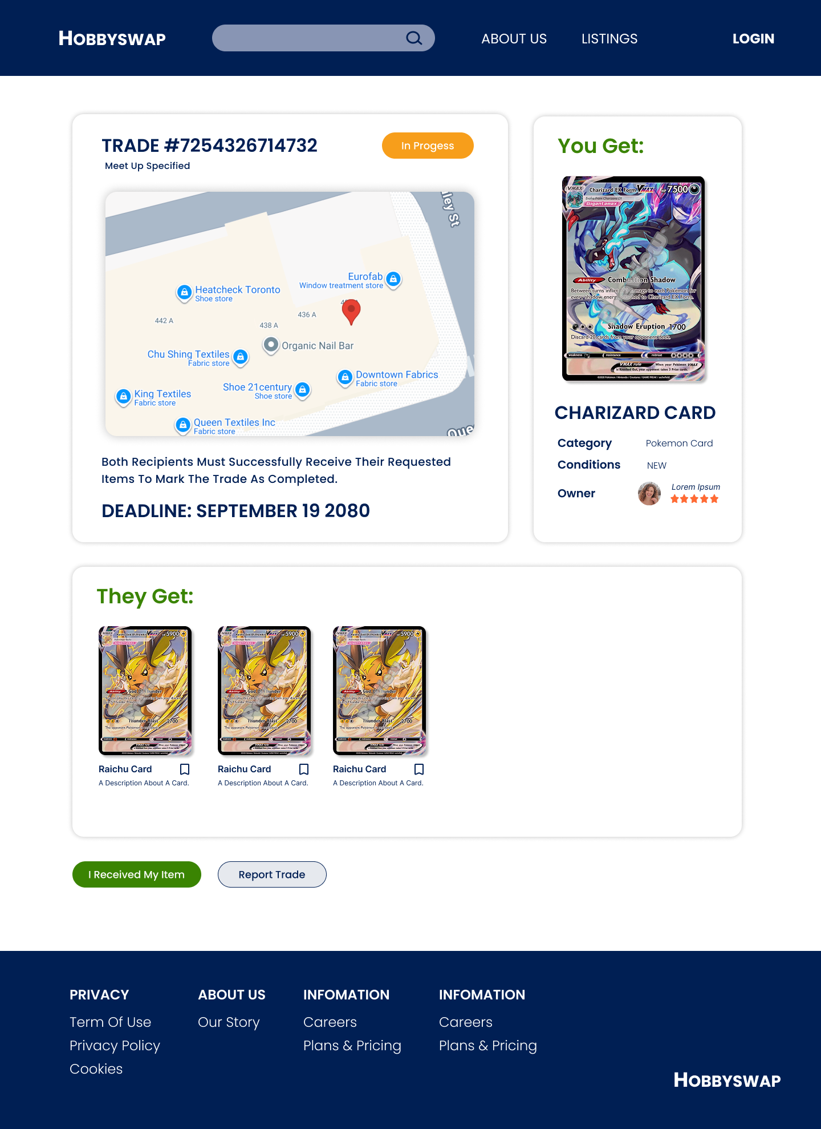

## 2.8.5 Profile Related Pages

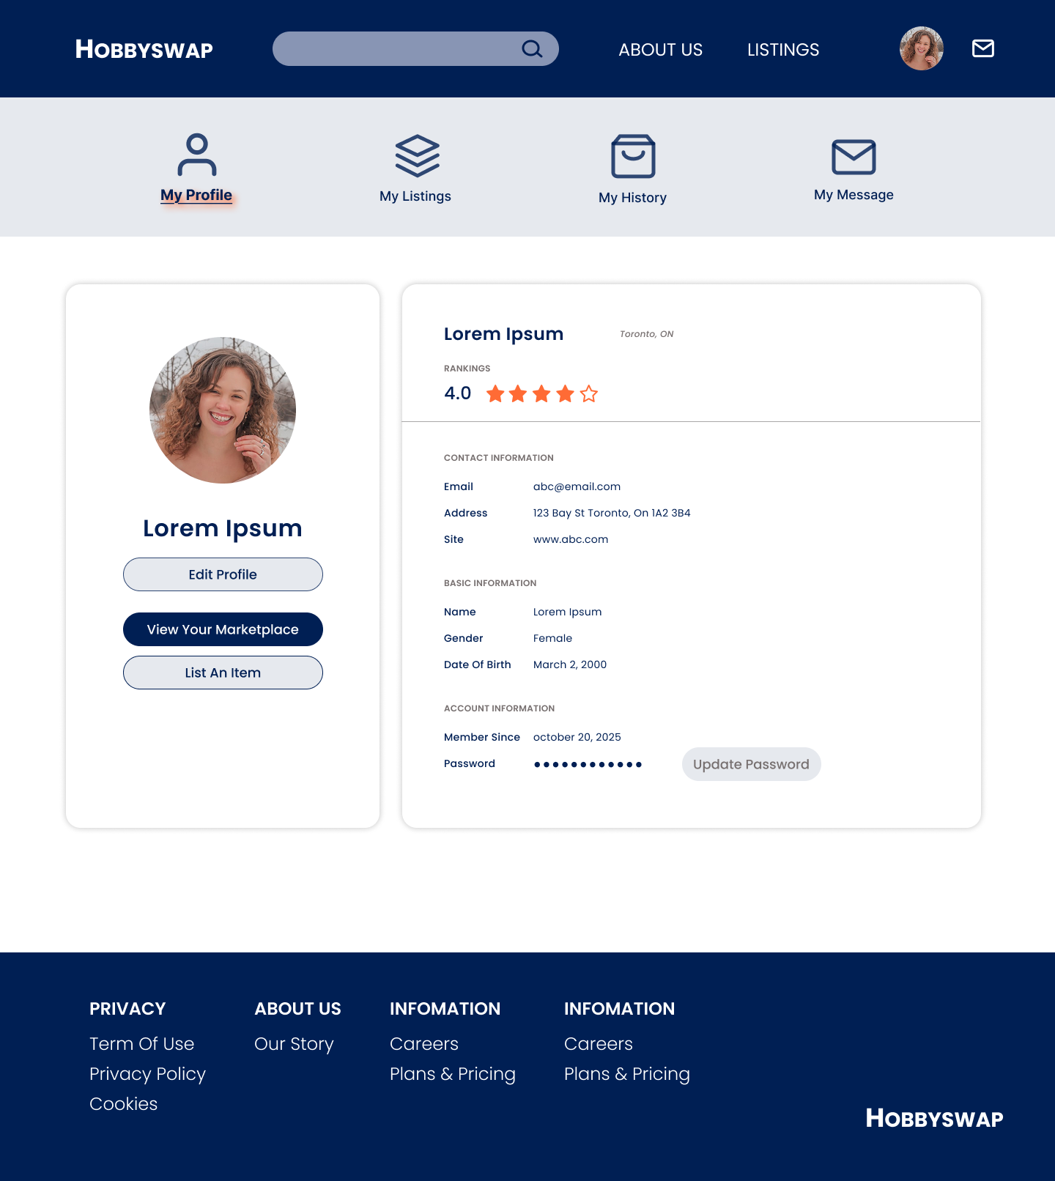

## 2.8.6 Review Related Pages

Item Review

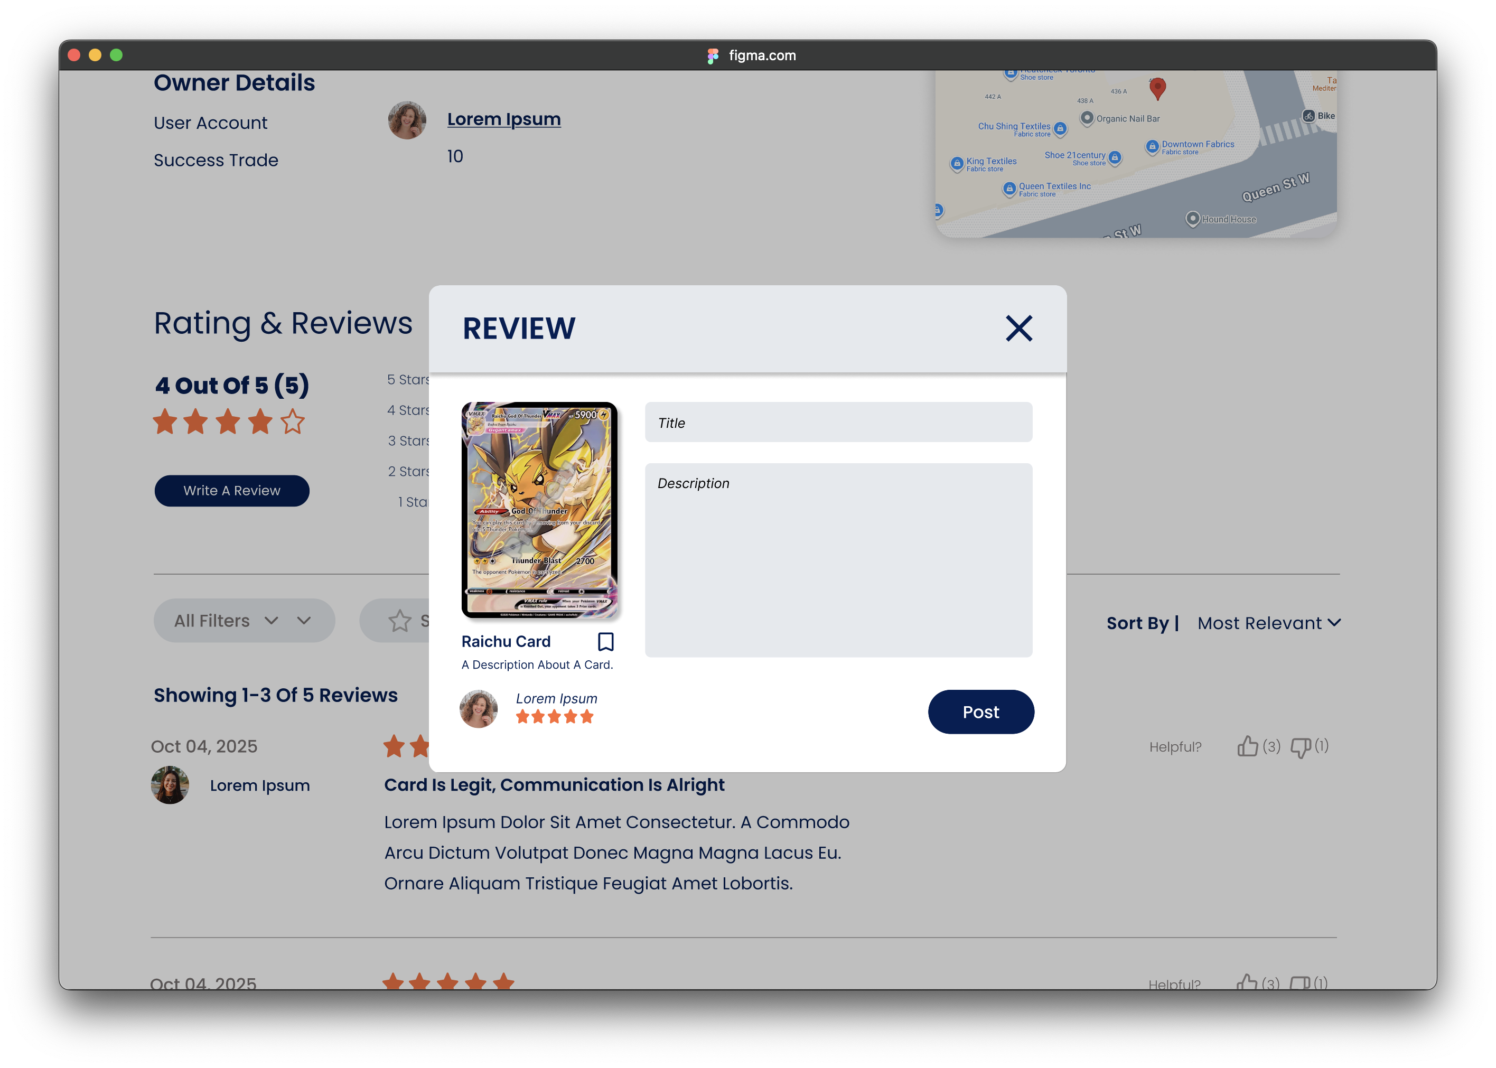

View Reviews Of User

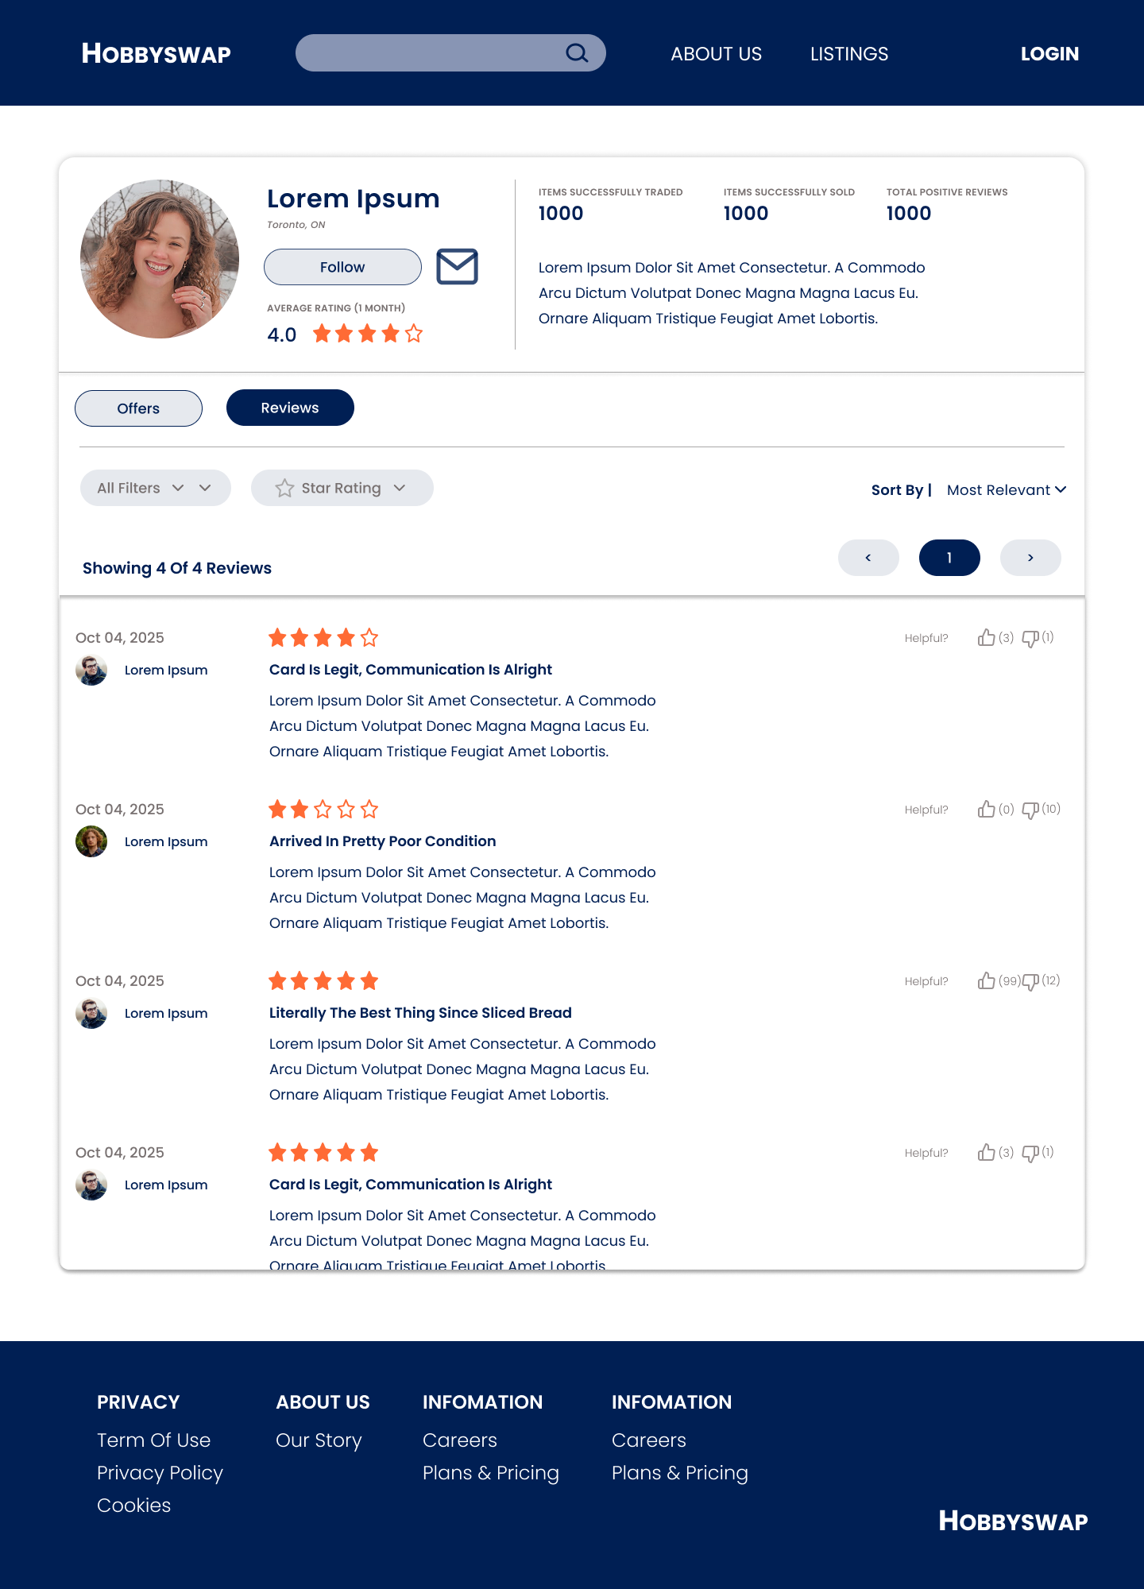

Section 3

# 3.1 Data Flow Diagrams

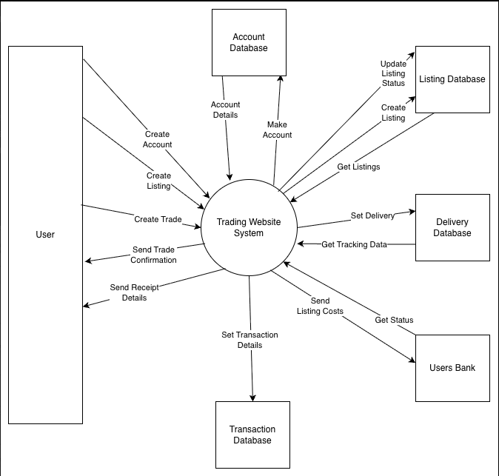

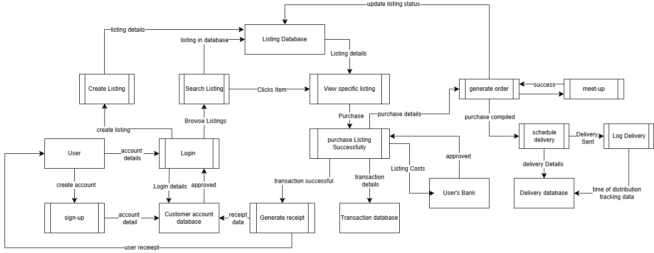

# 3.2 User Stories and related Use Case Scenarios

As a **visitor** of the platform, I want to **register** for a HobbySwap **account** so I can buy, sell and trade collectibles with other users.

|  |  |  |  |
| --- | --- | --- | --- |
| Use Case Name | Register Account | | |
| Triggering Event | Visitor wants to sign up for an account | | |
| Brief Description | Allows platform visitors to create accounts for HobbySwap | | |
| Actors | Visitor | | |
| Related Use Cases | Login, Delete Account | | |
| Preconditions | Visitor is on the HobbySwap Login page | | |
| Post Conditions | A unique account is created for the visitor | | |
| Flow of activities | Actor | | System |
|  | 1. | Select “Create A New Account” | Display form to prompt account information (First Name, Last Name, Username, Email, Password, Confirm Password) |
|  | 2. | Enter account information | Validate fields. Prompt for account type (Business/Regular User) |
|  | 3. | Enter account type | Display account information and account type and prompt for confirmation |
|  | 4. | Confirm account information and account type | Create a new account with a unique user ID. Set status to “Pending Verification”. Send verification email. |
|  | 5. | Check verification link in email | Update status to “Active”. Display confirmation message. |
| Exception Conditions | Visitor cancels the registration process | | |

As a **user**, I want to **create a listing** for my collectible, so I can **receive offers** from other users.

|  |  |  |  |
| --- | --- | --- | --- |
| Use Case Name | Create Listing | | |
| Triggering Event | User wants to list an item | | |
| Brief Description | Allow users to list items on the platform for others to see | | |
| Actors | User | | |
| Related Use Cases | Update Listing, Remove Listing | | |
| Preconditions | User is logged in on the platform | | |
| Post Conditions | A listing of the item is created and viewable by other users | | |
| Flow of activities | Actor | | System |
|  | 1. | Select “List An Item” | Display Fields for Listing Details. (Img(s)*, Item Name*, Condition*, Description*, Requested Item(s), Requestion Money, Meet Up (Location) |
|  | 2. | Enter Listing Details and Select “Post Offer” | Validate fields. Publish Listing. Display Listing with confirmation message. |
| Exception Conditions | User cancels the create listing process | | |

As a **user**, I want to **browse listings** so I can find **collectibles** I’m interested in.

|  |  |  |  |
| --- | --- | --- | --- |
| Use Case Name | Browse Listing | | |
| Triggering Event | User wants to browse items | | |
| Brief Description | Allows user to search, filter, and view collectible listings from other users | | |
| Actors | User | | |
| Related Use Cases | Create Listing, Send Trade Offer | | |
| Preconditions | User is logged in on the platform | | |
| Post Conditions | The system displays filtered results | | |
| Flow of activities | Actor | | System |
|  | 1. | Select “Browse Listing” | Displays all visible listings |
|  | 2. | Select filer (category, brand, price, location) | Displays the selected filtered results |
|  | 3. | Select a listing to view details | Display all item details, seller information, and available trade options |
| Exception Conditions | No listings found | | |

As a **user**, I want to **send a trade offer** for another user’s listings so I can **propose a swap or deal.**

|  |  |  |  |
| --- | --- | --- | --- |
| Use Case Name | Send Trade Offer | | |
| Triggering Event | User selects an item they want to trade for | | |
| Brief Description | Allows user to propose a swap or cash + item offer | | |
| Actors | User | | |
| Related Use Cases | Browse Listing, Message User | | |
| Preconditions | User is registered and logged in the platform  Selected item listing is active and available | | |
| Post Conditions | Offer is created and sent to the other user for negotiating | | |
| Flow of activities | Actor | | System |
|  | 1. | Select active listing and clicks “Send Trade Offer” | Displays offer form with fields for selected items, optional cash addition, and message |
|  | 2. | Enter offer details (items to trade, cash, and message) | Validate fields. Displays Fields of offer details. |
|  | 3. | Confirm and send offer | Creates trade offer record in database and sends notification to recipient user |
|  | 4. | Wait for reply | Displays confirmation message and moves offer to “Pending” status in trade dashboard |
| Exception Conditions | Invalid offer details | | |

|  |  |  |  |
| --- | --- | --- | --- |
| Use Case Name | Message User | | |
| Triggering Event | Users select other traders they want to talk for trading | | |
| Brief Description | Allows user to use the chatbot to communicate to each other | | |
| Actors | User | | |
| Related Use Cases | Create Listing, Send Trade Offer | | |
| Preconditions | User is registered and logged in the platform  Registered user with posting items can use chat box | | |
| Post Conditions | Message is sent to other user for negotiating or starting a trade | | |
| Flow of activities | Actor | | System |
|  | 1. | Select the available item with user. Click “send a message” | Display the chat box with the selected user |
|  | 2. | Enter the messages in chat box | Display the messages in chat box |
|  | 3. | Confirm and send | Create the messages in database and sends notification to other users |
| Exception Conditions | Unregistered users | | |

As a **user**, I want to **rate other users** while doing trading. From here, we can report scammer users.

|  |  |  |  |
| --- | --- | --- | --- |
| Use Case Name | Rate User’s transaction | | |
| Triggering Event | User wants to rate other users based on experiences in the past | | |
| Brief Description | Allows user to search, filter, and view collectible listings from other users | | |
| Actors | Pokémon card trader | | |
| Related Use Cases | Messaging and Review other User | | |
| Preconditions | User is logged in on the platform | | |
| Post Conditions | The system displays filtered results | | |
| Flow of activities | Actor | | System |
|  | 1. | Select “Rating User” | Displays all past transactions |
|  | 2. | Select chosen users | Displays all past rating from previous users |
|  | 3. | Select a listing to view details | Displays all item details, seller information, and available trade options |
| Exception Conditions | No listings found | | |

# 3.3 Activity Diagrams

**Register Account:**

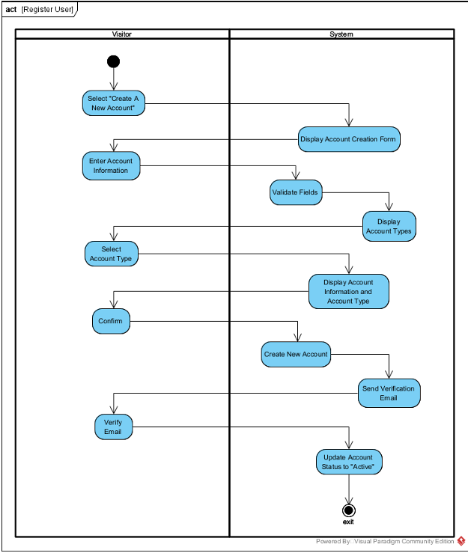

**Create Listing:**

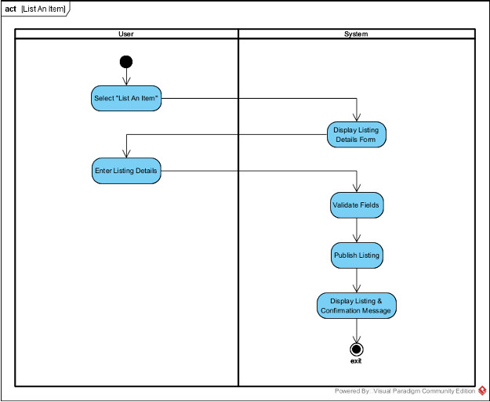

**Browse Listing:**

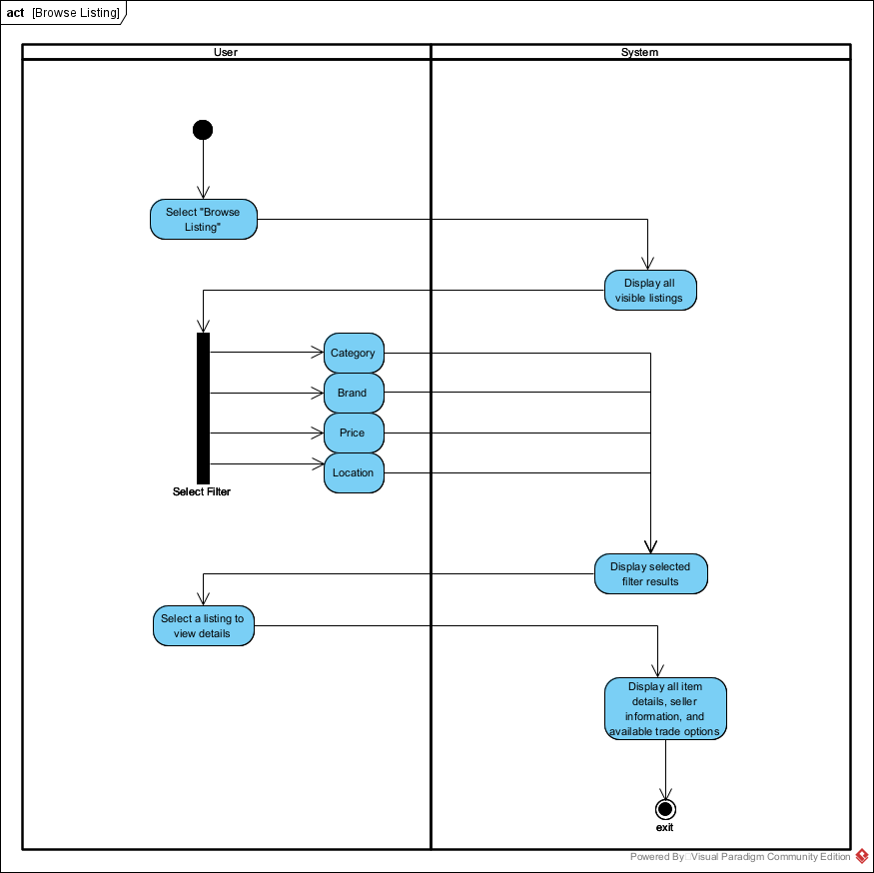

**Send Trade Offer:**

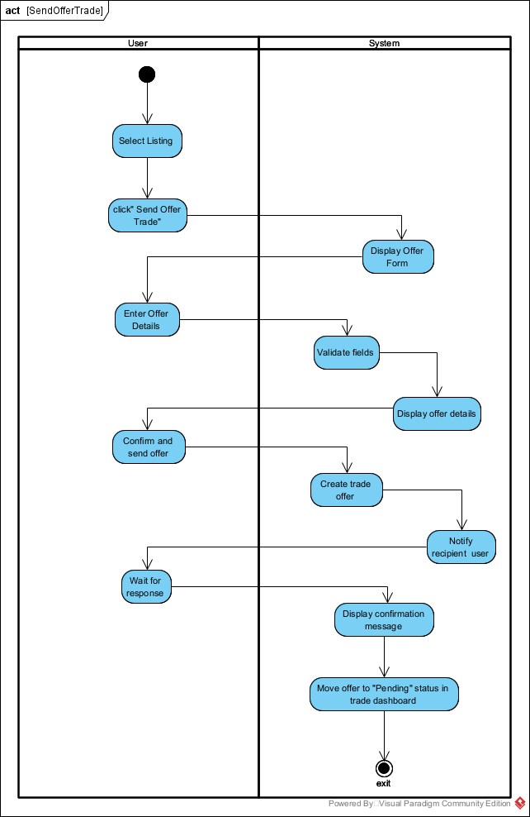

**Message User:**

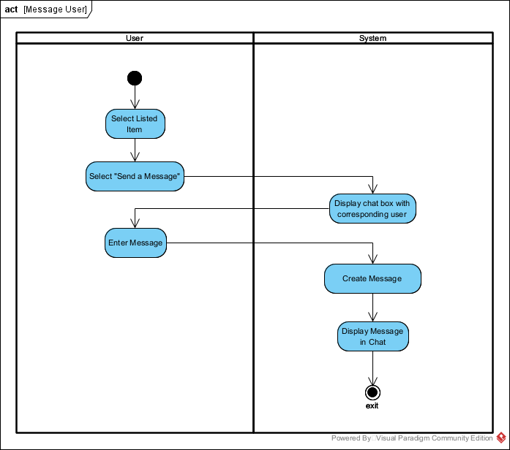

**Rate User Transaction:**

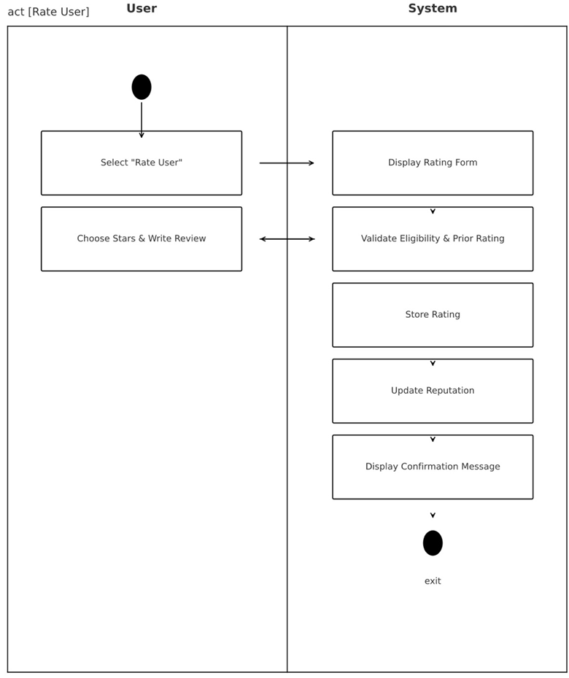

# 3.4 Business Rules

|  |  |  |  |  |
| --- | --- | --- | --- | --- |
| **Business Rule #** | **Description** | **Activity Diagram** | **Related UCS** | **UI**  **Mock-up** |
| BR1 | Users must be registered and verified before initiating trades | AD1 | UC1 | UI 2.8.1 |
| BR2 | Users can create, edit, or delete their collectible listings. | AD2 | UC2 | UI 2.8.2 |
| BR3 | Users can search and filter listings by category, brand, or type. | AD3 | UC3 | UI 2.8.3 |
| BR4 | Users can message owner for more listing details | AD3 | UC3 | UI 2.8.4 |
| BR5 | Offers can be sent, accepted, or declined only by verified users. | AD5 | UC4 | UI 2.8.4 |
| BR6 | Trades require confirmation from both parties before processing | AD6 | UC5 | UI 2.8.4 |
| BR7 | User will be able to view and edit their account information | AD7 | UC6 | UI 2.8.5 |
| BR8 | User will be able to view ratings and rate other users | AD8 | UC7 | UI 2.8.6 |

Section 4 – Domain Class

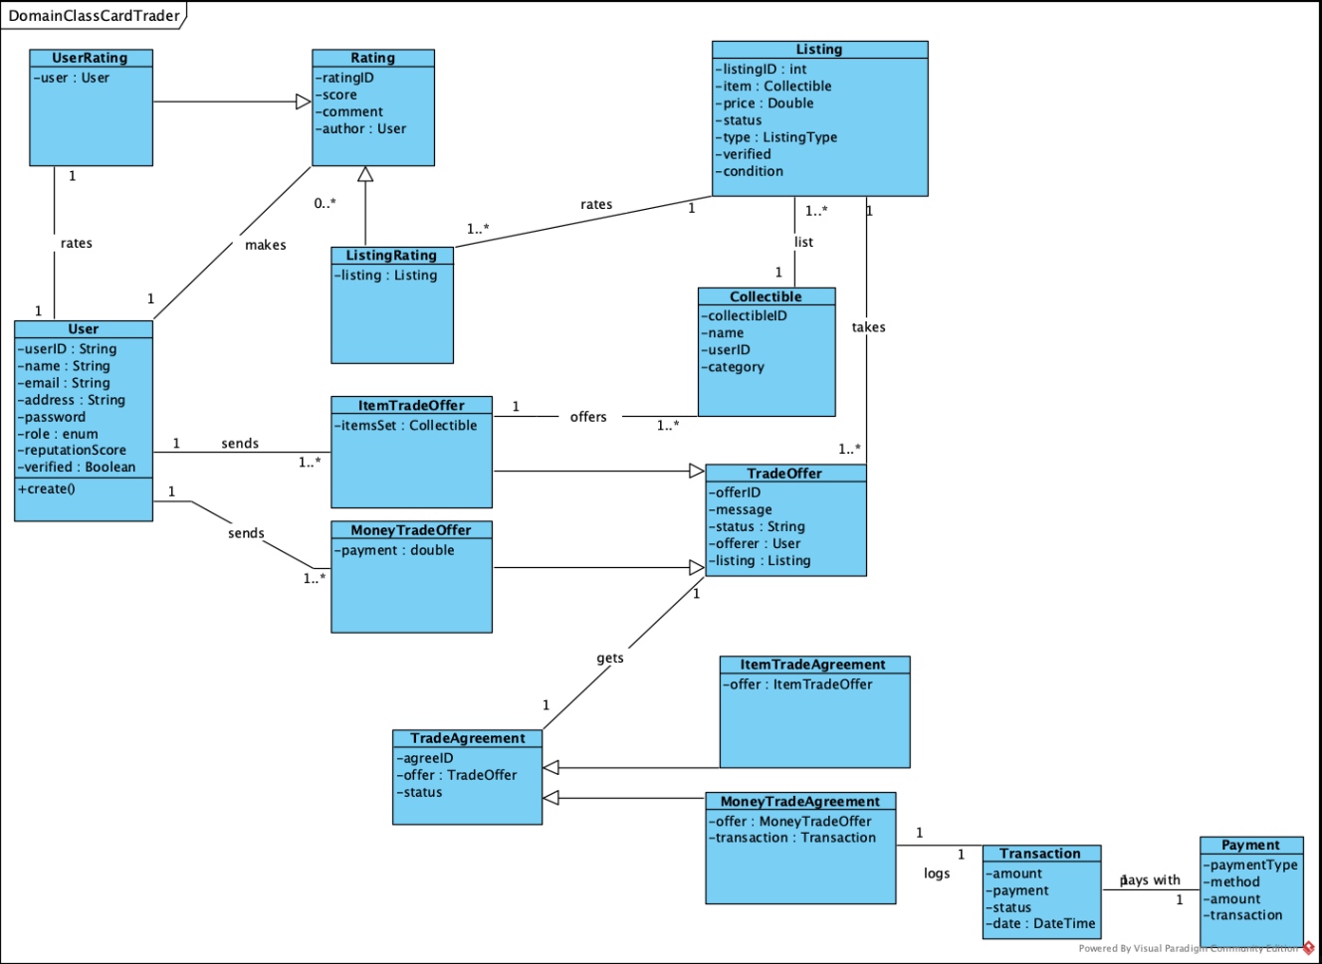

Section 5 – Database

For HobbySwap, a NoSQL document-base database is best fit, we chose MongoDB, since it is a web platform and relies heavily on flexible, relationship-driven data, such as Users, Listing, Trade Offers, Messages and Reviews. These records vary in structure and grow dynamically as the platform expands MongoDB’s schema flexibility allows new fields to be added in the future, such as negotiation feature, additional item details, without breaking anything.

The database design uses separate collections for core entities, Users, Listing, TradeOffers, Messages, Reviews, and Categories, make sure that it easy to query.

# 5.1. Architecture Overview

* **Back-end Framework**: Node.js + Express
* **Database:** MongoDB
* **ORM/ODM:** Mongoose
* **Authentication:** JWT + hashed passwords (bcrypt)

# 5.2 Collections

**User Collection**

|  |  |  |
| --- | --- | --- |
| **Field** | **Type** | **Description** |
| _id | string | Unique user identifier |
| firstName | string | User’s first name |
| lastName | string | User’s last name |
| username | string | Unique username for login |
| email | string | Email address |
| hashPassword | string | Store hash password only for security |
| verified | boolean | If account is verified |
| ReputationScore | number | Average rating from completed trades |
| ratings | Array of sub-documents | Feedback from other users |
| → raterId | string | The user’s id |
| → score | number | Rating value (1-5) |
| → comment | string | Optional feedback message |
| createdAt | Date (ISO string) | Date of account creation |

Relationship: A User can create multiple **Listings**, send and receive **TradeOffers**, exchange **Messages**, and give/receive **Reviews**

**List Collection**

|  |  |  |
| --- | --- | --- |
| **Field** | **Type** | **Description** |
| _id | string | Unique listing identifier |
| userId | string | Reference to User._id |
| title | string | Title of the collectible |
| description | string | Item details |
| category | string | Collectible category |
| brand | string | Brand name (ex. Pokemon) |
| condition | string | Item condition (ex. Used, new) |
| images | Array of strings | [URLs, pngs, jpeg] |
| requestedTrade | document | Trade details |
| → preferredItem | string | Desired collectible |
| → cashOption | number | Optional cash top-up |
| status | string | Listing status in an enum [ ACTIVE, COMPLETE, PENDING] |
| location | string | City or region of seller |
| datePosted | Date (ISO string) | Listing creation date |

Relationship:A listing belongs to only one **User**, and can have multiple **TradeOffers**.  
  
**TradeOffers Collection**

|  |  |  |
| --- | --- | --- |
| **Field** | **Type** | **Description** |
| _id | string | Unique offer identifier |
| senderId | string | Reference to User._id (Who ever sent the offer) |
| receiverId | string | Reference to User._id (Who is the listing owner) |
| offeredItems | Array of strings | IDs of items the sender offers |
| requestedItems | Array of strings | IDs of items requested |
| cashOffer | number | Optional cash add |
| message | string | Optional way to negotiate |
| status | string | Status enum [ Pending, accepted, declined] |
| ListingId | string | Reference to Listing._id |
| createdAt | Date (ISO string) | Offer created time |

Relationship: Each **TradeOffer** connects two **Users** and a **Listing**.\

**Messages Collection**

|  |  |  |
| --- | --- | --- |
| **Field** | **Type** | **Description** |
| _id | String | Unique message Identifier |
| senderId | string | Reference to User._id |
| receiverId | string | Reference to User._id |
| tradeOfferId | string | Reference from TradeOffers._id |
| message | string | Message text |
| read | boolean | Whether message has been seen or not |
| timestamp | Date (ISO string) | Message creation date/time |

Relationships: **Messages** can allow **two Users** to negotiate and create a **TradeOffer**.  
  
**Reviews Collection**

|  |  |  |
| --- | --- | --- |
| **Field** | **Type** | **Description** |
| _id | string | Unique review identifier |
| reviewerId | string | Reference to Users._id |
| revieweeId | String | Reference to Users._id |
| tradeOfferId | string | Reference from TradeOffers._id |
| rating | number | Rating value (1-5) |
| comment | string | Optional feedback message |
| createdAt | Date (ISO string) | Review created timestamp |

Relationships:Each **Review** references **two Users** and a completed **TradeOffer**.  
  
**Categories Collection**

|  |  |  |
| --- | --- | --- |
| **Field** | **Type** | **Description** |
| _id | string | Unique category identifier |
| name | string | Category name |
| description | string | Brief explanation of the category |

Relationships: A **Category** has many **Listings**.

*\* Conceptual Relationship Diagram:*

Users ←→ Listings → 1-to-many

Users ←→ TradeOffers→ many-to-many

Listings ←→ Categories → many-to-1

Users ←→ Reviews → 1-to-many

# 5.3 Data Sample

**Users Collection Document**

*{*

*"_id": "user_1",*

*"firstName": "John",*

*"lastName": "Doe",*

*"username": "johndoe",*

*"email": "johndoe@hobbyswap.com",*

*"hashPassword": "johndoe123HS",*

*"verified": true,*

*"reputationScore": 4.0,*

*"ratings": [*

*{ "raterId": "user_2", "score": 5, "comment": "Smooth transaction!" }*

*],*

*"createdAt": "2025-11-14"*

*}*

**Listings Collection Document**

*{*

*"_id": "listing_1",*

*"userId": "user_1",*

*"title": "Pokemon Charizard",*

*"description": "Mint condition graded already with a rating of 9 from PSA.",*

*"category": "Trading Card",*

*"brand": "Pokemon",*

*"condition": "New",*

*"images": ["https://cdn.hobbyswap.com/items/PokemonCharizard.png"],*

*"requestedTrade": {*

*"preferredItem": "None",*

*"cashOption": 250*

*},*

*"status": "active",*

*"location": "Toronto, ON",*

*"datePosted": "2025-11-20"*

*}*

**TradeOffers Collection Document**

*{*

*"_id": "offer_110",*

*"senderId": "user_2",*

*"receiverId": "user_1",*

*"offeredItems": ["listing_10"],*

*"requestedItems": ["listing_1"],*

*"cashOffer": 25,*

*"message": "Would you consider this swap + $25?",*

*"status": "pending",*

*"createdAt": "2025-11-21"*

*}*

**Messages Collection Document**

*{*

*"_id": "msg_10",*

*"senderId": "user_2",*

*"receiverId": "user_1",*

*"tradeOfferId": "offer_110",*

*"message": "Hey! Can you take a photo of the Pokemon card’s back side?",*

*"timestamp": "2025-11-21",*

*"read": false*

*}*

**Reviews Collection Document**

*{*

*"_id": "review_20",*

*"reviewerId": "user_1",*

*"revieweeId": "user_2",*

*"tradeOfferId": "offer_110",*

*"rating": 5,*

*"comment": "Item exactly as described — great trader!",*

*"createdAt": "2025-11-22"*

*}*

**Categories Collection Document**

*{*

*"_id": "charizard_1",*

*"name": "Pokemon Charizard Card",*

*"description": "Pokemon Charizard card rating PSA 9"*

*}*

Section 6 – Project Management

# 6.1 Work Breakdown Structure

# 6.2 Milestones & Acceptance Criteria

Section 7 – Product Backlog & Implementation Schedule

Section 8 – Client/Faculty Sign-off

# References

eBay. (n.d.). *eBay.* Retrieved September 25, 2025, from <https://www.ebay.com>

Facebook. (n.d.). *Marketplace.* Facebook. Retrieved September 25, 2025, from <https://www.facebook.com/marketplace>

StockX. (n.d.). *StockX.* Retrieved September 25, 2025, from <https://stockx.com>